Mysterious Races
Gowachin: A race of leaping strategists

Grosh: A race of poisonous thugs
Klendatu: A race of raptor-like hunters
Kroot: a savage race of avian raiders
Salaman: a nonviolent race of amphibians
Sathar: A vile race of worm-like invaders
Saurian: A race of reptilian biped refugees
Zuraqqor: An evil race of flying insectoids

Gowachin
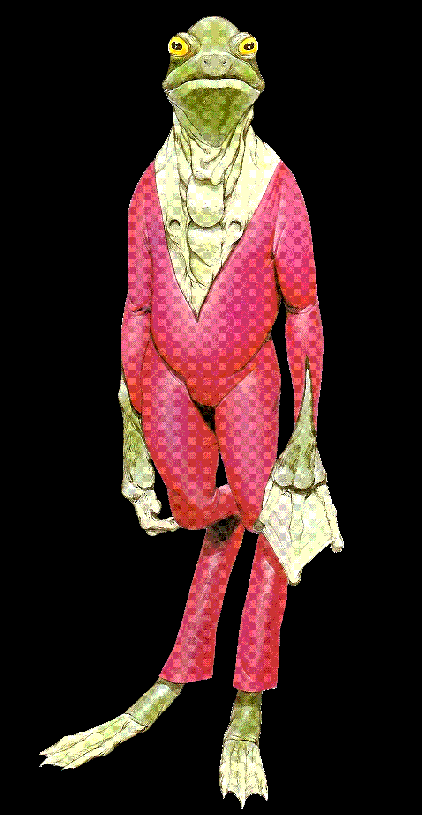
_________________________________________________
AVERAGE SIZE: 2 meters tall
AVERAGE MASS: 70 kg
AVERAGE LIFESPAN: 80 years
REPRODUCTION: Heterosexual, oviparous
BODY TEMPERATURE: 35 C
TYPE: carnivore
Source:"Barlowe's Guide to Extraterrestrials"
____________________________________________
Physical Appearance and Structure
The Gowachin are amphibious, froglike beings. Their skin is smooth, wet, pale green, with webbing between three long fingers and toes. The fingers have four-centimeter-long fighting claws that are retractable. The Gowachin have lungs, used when on land, but they also have greenish-white gill-like ventricles on the chest, which are used to extract oxygen from water. When a Gowachin is out of water, the ventricles tend to open and close rhythmically and involuntarily.
The Gowachin has no rib cage, making its torso flat and narrow. The heart is located in the lower abdominal area.
Senses
Gowachin senses of sight, taste, touch and smell are the equivalent of Human norm. Their sense of hearing, however, is not as quite developed as that of Humans.
Speech
Gowachin speech is low and raspy, interupted with occassional croaks, ribbets, and burping sounds. Besides their own language, Gowachin are able to learn and communicate in PanGal.
Society and Customs
Gowachin society is structured around large extended families, or phylums, each of which owns a huge family hall. A Gowachin's phylum affiliation is indicated by tatoos on its eyelids. Most members of a phylum are born into it, but itis possible for outsiders to make an application to join a new phylum.
Gowachin believe that their females have little intelligence, and no function beyond breeding. The females are sequestered in the graluz, or breeding pool, deep inside the Gowachins' house. The graluz is accessible only through underwater tunnels. There, the young tads are hatched. It is also in the graluz and tunnels that the adult males subject the tads to the weeding frenzy, chasing and killing all those not swift and strong enough to escape.
The Gowachin live on many planets, but their home world is called Tandaloor. They live as much in water as out of it, with waterways connecting their buildings and serving as passageways within their homes.
Gowachin thought is consumed with tactical and strategic concepts, not only as a military art, but also as a form of intellectual entertainment. They love to spend long hours playing challenging strategic games or discussing tactical concepts.
Attitudes
Gowachin seems to get along with most races, although they tend to show a complete lack of respect for insectoids races such as the Vrusk and Zuraqqor, and for worm-like races such as the Sathar and S'sessu. This negative attitude is believed to originate from the Gowachins' perception that insects and worms are nothing more than delicious food sources, and have been the mainstay of their races' diet for countless generations.
Special Abilities
Leaping: A Gowachin can leap up to 10 times its own body length (20 meters).
Battle Strategy: Gowachin have the innate ability to quicky perceive the best method of attack in any battle situation. When a Gowachin is in command of a tactical unit or group and successfully rolls its Battle Strategy score, all beings within that group receive an additional +5% to their attack rolls. Coversely, all beings of the opposing group receive a -5% penalty to their attack rolls.
The Gowachin player character begins the game with a Battle Strategy score of 10%, which can be improved with experience points (see IMPROVING CHARACTERS in the Alpha Dawn expanded rulebook)

Grosh
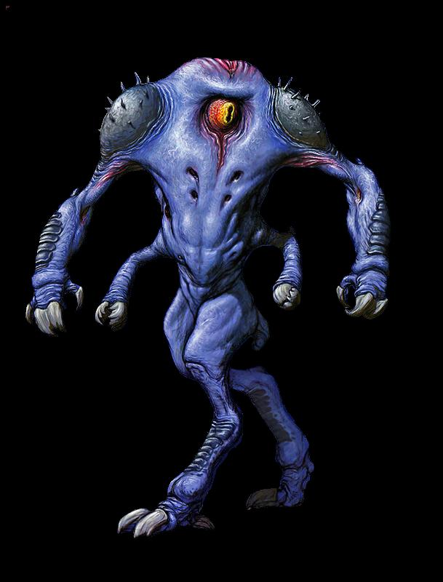
_____________________________________________
AVERAGE SIZE: 2 meters tall (male), 3 meters tall (female)
AVERAGE MASS: 100 kg (male), 150 kg (female)
AVERAGE LIFESPAN: 75 years (male) 150 years (female)
REPRODUCTION: heterosexual, oviparous
BODY TEMPERATURE: 35 C
TYPE: omnivore
Art: Miles Teves
_____________________________________________
Physical Appearance and Structure
Grosh are a sentient race of bipedal mammals with a conjoined head, thorax and abdomen. Their thick leathery hide is blue in color and partially covered with spine-like protrusions (males) or long hairy clumps (females). Grosh have two arms very much like a Yazirian's with regards to muscle and joint placement. Each of their two hands have three clawed fingers and an opposing clawed thumb for grasping and manipulating objects. The Grosh's legs appear avian in structure, and their two anisodactyl feet each have four clawed toes.
Grosh are a cycloptic species, having one large eye centrally located between its upper shoulders. The thick left/right closing eyelids are connected in such a manner as to follow the creature's normal eye movement while providing protection from injury to the eye globe. Other unique features of the Grosh anatomy include its four breathing holes which are located in the front of the thorax, its two ears on the flanks of the thorax, and its "marms" which are arm-like feeding stalks that protrude from the sides of the abdomen. Each marm has a sharply toothed mouth used for mastication and also vocalization.
Grosh females are larger in both size and mass than the Grosh males, and are much prized by individual gangs of Grosh males that are fortunate enough to have any females living among them. A Grosh female is able to produce literally thousands of eggs during her lifetime, with a full 95% of the hatchlings being male and only 5% being female. Offspring of either gender seem to mature quicky as compared to other known races, and will reach full adulthood within approximately 10 years of birth.
Senses
Grosh are similar to Humma with regards to their senses of smell and taste. Its hearing is slightly poorer than that of a Human's, and although a Grosh can see nearly as well as any Human, the absense of a neck obligates them to alter their body stance in order to view a 180 degree field of vision. The Grosh eye has two pupils that are oriented vertically to each other which provides for the depth perception of objects.
Speech
Grosh speech is odd for most races to listen to. The Grosh use both of their marms or mouth stalks in an alternating fashion while speaking, occassionally pronouncing certain words using both mouths at the same time. Grosh prefer to speak using their own language. They will however speak a crude form of PanGal if it is necessary for them to do so.
Society and Customs
Grosh society is organized into loose associations of what most races would consider to be thuggish gangs. The individual Grosh gang compete for power and overall dominance within their society. Each gang is controlled by its own leader or 'boss' who is the most powerful, intelligent or ruthless member among their number. Violent skirmishes between Grosh gangs is common place, and since their recent expansion into the Frontier, the gangs have continued to skirmish for new territories in order to extort weapons, equipment, minerals, technology and other valuables.
Grosh will outwardly insist to UPF authorities that they are merely peaceful explorers amd merchants who wish nothing more than to open up new trade routes and enrich themselves in the various cultures of the Frontier. They will never directly challenge any force that they perceive is more powerful than their own, and the UPF for their part deals with any Grosh criminal activity on a case by case basis.
Attitudes
Grosh are arrogant and bruttish in the extreme unless they are confronted by obviously more powerful individuals or groups. If they perceive fear or weakness in any social dealing, they will almost always attempt to exploit those involved. Grosh will at times recruit members of other races into their gangs if they feel that these individuals can be an asset to their gang at some point.
No gang member, Grosh or otherwise, is ever allowed to renounce their allegiance to that particular gang. Any individual attempting to do so can expect an immediate and violent response from the gang's leader and members.
Special Abilties
Poison Claws: Grosh claws contain a toxin that is sucreted by glands located at the base of each talon. The toxin (S5/T2) has a 30% chance of causing partial or complete paralysis in any creature scratched except for those races that are immune to poisons in general. This fact is not generally known by the other races, and unless told, the player characters will need to learn this fact on their own. Any Grosh fighting hand-to-hand are allowed three attacks per turn; either two clawing attacks and a bite, or two biting attacks and a claw. A successful clawing attack does 1d10 points + PS damage (+ STA check to resist the poison), and the bite with inflict 1d5 points of damage.
ABILITY MODIFIERS: STR/STA: +20 DEX/RS: +0 INT/LOG: -20 PER/LDR: +0, MOVEMENT: Human

Klendatu
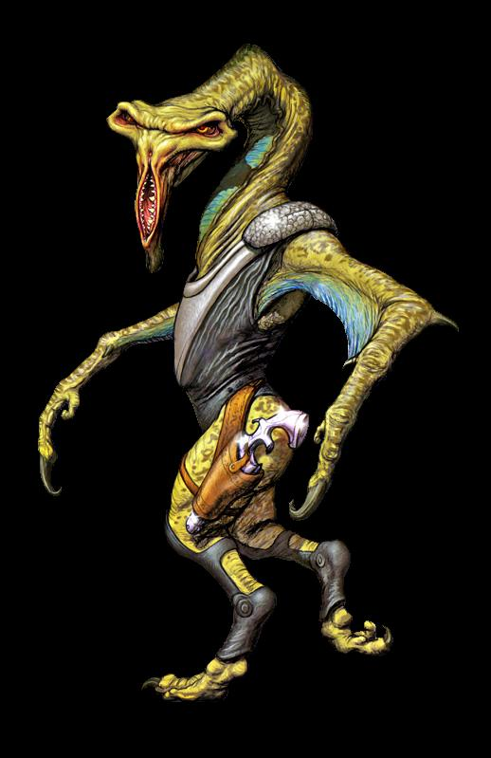
____________________________________________________
AVERAGE SIZE: 2 to 2.7 meters tall
AVERAGE MASS: 75 kg
AVERAGE LIFESPAN: 100 years
REPRODUCTION: heterosexual, oviparous
BODY TEMPERATURE: 39 C
TYPE: carnivore
Art: Miles Teves
____________________________________________________
Physical Appearance and Structure
Klendatu are a race of bipedal carnivores that exhibit both humanoid and raptor-like anatomical traits. The most distinctive of these are the Klendatu's T-shaped head, its vertically shaped mouth, and its long snake-like neck. The Klendatu's height will vary as much as .7 meters due to the length of its neck and its head position relative to its shoulders.
A Klendatu can easily turn its head up to 270 degrees left or right from the forward facing position due to its neck having more than twice as many vertabrae as those found in either Humans or Yazirians. Klendatu also have a special arrangement of the jugular veins and associated blood vessels that ensure its blood supply and return are not impeded as the neck is rotated. This allows the Klendatu's head to look in most any direction for long periods of time without having to adjust its relative body positioning.
The Klendatu's two hands each have one long, taloned finger and a shorter opposable thumb. While not as dextrous as most other races, the Klendatu's hand structure is most efficient when moving through the thick brush and tangled forests of their homeworld. Since the development of advanced technology however, many Klendatu have opted for the assistance of mechanical devices such as multi-fingered robotic gloves to augment their digital shortcomings.
The Klendatu's two eyes are yellow in color with piercing red pupils. Unlike many known species, Klendatu have one enlongated 'ear' located on the anterior surface of their throat. This sensitive organ reaches from the middle of their neck to the top of their chest and is very sensitive to even the slightest vibrations. The Klendatu's legs and feet also appear to be raptor-like in structure, with both feet having short, razor-sharp talons.
The Klendatu possess the evolutionary remnants of wings which are located between the thorax and forarms. These mere flaps of skin no longer impart the same gliding or flight capabilities that they once did many thousands of years ago.
Senses
Due to their predatory nature, Klendatu have highly developed senses of sight, smell, taste and hearing. Their sense of touch is less than adequate however and Klendatu seem to have difficulty whenever attempting to identify the various surface textures of objects.
Speech
Klendatu speak mostly in hissing whispers with occassional low level squawks. Although they are fully capable of communcating in PanGal, Klendatu prefer to speak their own language while being assisted by the use of polyvoxes.
Society and Customs
As the Klendatu are first and formost a predatory species, they have developed a culture that values the concept of hunting creatures that they interpret as 'worthy prey'. Within their society, the more dangerous or cunning a hunted creature is, the greater the prestige the hunter will hold among his or her peers. The Klendatu are also known to take trophies of their most worthy kills. While this can be almost any part of a slain creature's anatomy, it will normally be a part that is unique to that creature (horns, ears, tail, hide, wings, tongue, skull, claws, etc.) The trophy will then be displayed on the Klendatu's person, in its domocile or on the walls of its starship if it owns one.
A notable aspect of the Klendatu hunt is that they do not always kill the prey that they have successfully tracked down. While only an individual Klendatu can explain its reasoning for this, it is generally believed that while all Klendatu are enthusiastically comitted to the hunt, actually killing the prey is subject to the Klendatu's choice. As a general rule, prey that has come to earn the Klendatu hunter's respect will often times be granted its life at the conclusion of the hunt.
The smallest unit in Klandatu society is the "Den", which is composed of several mutually supporting families that live together in nearby dwellings. Clusters of Dens are organized into 'Holdings' that are each overseen by a 'Hunter Council'. These councils in turn are collectively ruled by the "Council of the Great Slayers", a governing body that consists of the most successful hunters living among the Klendatu society on their homeworld.
Bonding among Klendatu involves a special ritual called the "Blood Kin Meal" wherein two individuals who are not otherwise related drink a small amount of each other's blood and thus become 'blood kin' for life. It is very rare for Klendatu to conduct the blood kin meal ritual with an individual of another race, but it has been known to happen if the outsider has saved the Klendatu's life or has otherwise been a valued companion for many years.
Attitudes
Klendatu are respectful of the Yazirians as they consider them to be a kindred race. They admire the Vrusk for their no nonsense approach to most situations, and also the Humma for their fighting abilities. They tend to dislike Dralasites however as the Klendatu consider their race to be "a slow moving race of frivalous comedians who are easily captured".
The Klendatu generally view of Humans with suspicion due to the wide variance of behaviors that their race exhibits in their social dealings. Klendatu are generally neutral towards all other known races which unfortunately includes the Sathar and the Zuraqquor.
Special Abilities
Hunter Sense: Klendatu are perhaps the best hunters in known space. They receive a +20% bonus when performing any of the enviromental skills listed in the STAR FRONITERS EXPANDED GAME RULES including the concealment, tracking, and stealth skills. They can also apply their Hunter Sense bonus to any single aimed shot from a weapon they are familiar with. The bonus is in addition to the normal bonus characters receive when using 'Careful Aim'. The Klendatu's special ability can be improved by using skill points earned during the course of the game.
Long Endurance: A Klendatu can move at a jogging pace for as many turns as it has Stamina (STA) points.
ABILITY MODIFIERS: STR/STA: +0 DEX/RS: +10 INT/LOG: +5 PER/LDR: -5, MOVEMENT: as Vrusk (no penalties when moving through thick brush, jungle or woodland enviroments)

Kroot
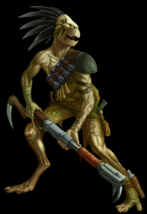
_______________________________________________
AVERAGE SIZE: 2 meters
AVERAGE MASS: 70 kg
AVERAGE LIFESPAN: 100 years
REPRODUCTION: heterosexual, oviparous
BODY TEMPERATURE: 38 C
TYPE: carivore
Source: Warhammer 40K
__________________________________________
Physical Appearance and Structure
The Kroot are humanoid in appearance, resembling carrion-eating avian creatures. They have inverted raptor jaws. Their bone structure is light due to the Kroot's avian ancestry. They have four digits on their hands (arranged in a zygodactylic form) and feet. Their heads are crowned with tough quills or spines that form part of their sensory apparatus; these connect to the brain via ganglia. Kroot eyes have no pupil and are generally milky white in coloration allowing them to see into the darkness, allowing the Kroot to track their prey even at night. Kroot live in jungles in clans called Kindreds.
A Kroot's skin colour is naturally muddy-grey but the parents' offspring's skin depends on whatever animal the parents consumed (e.g. parents who consumed many goblins before the child's birth then the child's skin would be a muddy orange or a grey/orange).Kroot are thin and wiry, being on average half a foot taller then humans and about the same weight. They reach adulthood at age 12 and usually live up to 100 years. The Kroot favour primitive garb worked from the hides of animals and adorned with bones, handcrafted amulets and circlets.
Senses
The Kroot's senses of sight, hearing and smell are superior to those of Humans. Their senses of taste and touch are not as well developed as those of Humans.
Speech
It is suspected that the Kroot leave pheromone trails, mark territories, leave warnings and even communicate with one another, to some extent with scent. This may also be some form of control that extends to lower life forms such as birds and animals, as there is evidence to suggest that the Kroot employ empathic pheromones to prevent such creatures from being startled by them and giving away their position in battle. Combined with their method of communication, the Kroot can learn new languages at an astounding rate, matching posture and tone to the sound of foreign words in order to discern their meaning. Their own verbal communication is a mixture of clicks and whistles, possibly reinforced by these pheromone exudations. Kroot language is called Kroot and is found very difficult by the few who attempt to learn it, due to having a different larynx format. There is no alphabet to the Kroot language, Kroot favor simple scrawlings and pictograms on the rare occasion anything needs to be written down.
Society and Culture
There is no chief Kroot deity, Kroot clerics occasionally follow Obad-Hai, but usually follow none at all. When a Kroot cleric worships no God, he commmonly chooses between Animal, Plant, Strength and Water as his domains, although having no God he may choose any he pleases. Most Kroot believe that when a warrior of any race dies, his warrior spirit should be kept, and the only way to do this is by eating his flesh. The Kroot practice this in their "burial" customs, in which the body of the deceased is consumed by the kindred.
Attitudes
Kroot treat everyone passing through their jungle with a degree of suspicion, hands on their weapons just incase. Outside of the jungle, Kroot promote the same loyalty to their clan and comrades as do although they are much more suspectible and welcome to change. In general, Kroot are wary, some unfriendly to anyone they haven't met, and respect is slowly earned, most often through martial prowess. When a Kroot has made an alliance, they will be loyal for life.
Special Abilities
Bite: Kroot can delivery a serious bite with their beaks, which does 2d10 + PS damage.

Salaman
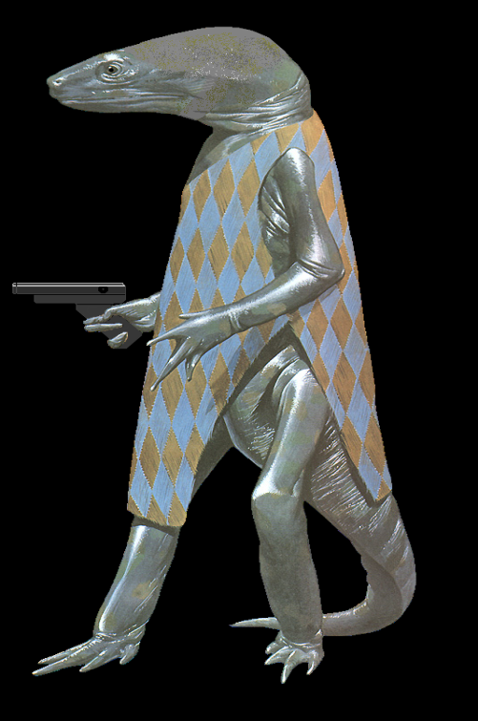
___________________________________________
AVERAGE SIZE: 1.7 meters
AVERAGE MASS: 60 kg
AVERAGE LIFESPAN: 70 years
REPRODUCTION: heterosexual, oviparous
BODY TEMPERATURE: 26.5 C
TYPE: Omnivore
Source: Barlowe's Guide to Extraterrestrials
___________________________________________
Physical Appearance and Strucrure
Salamen are a race of sentient bipedal amphibians. Each Salaman has two arms and two legs, with each hand having four fingers and each foot having four toes. Two eyes and a mouth are located towards the end of their long head, and its long non-prehensile tail serves to stabilize the creatures while walking or swimming.
Young Salamen are pale blue, dapped with brown and green; the blue pigment darkens to nearly black as they mature. They shed their skins frequently. Skin coloration is affected by climate and surroundings, and being so will notably change daily.
The Salamen have a very complex life cycle, which allows them to live both on land and in the water. Eggs are laid in the water, encased in gel clusters. These eggs hatch into young aquatic Salamen, who mature as water breathers until they reach the point of metamorphosis into adults. At this time, the young Salaman may choose to change either into an adult aquatic form or a juvenile air-breathing land form. If it chooses to become a land dweller, it continues to develope until it must once again choose whether to metamorphose into an adult land dweller or to revert to the juvenile aquatic form. Once the Salaman has chosen to change into an adult form, it can change at will from adult land dweller to adult water dweller and back. At any one time, about half the Salaman population is in each form.
Senses
Salamen senses of sight and hearing are not as well developed as those of Humans. Their senses of taste, touch and smell are about the same as those of Humans however.
Speech
The Salamen have a complex language of hand signs, used both on land and in the water. The land dwellers also use a simple vocabulary of barking and whistling sounds. They are able to learn to speak PanGal.
Society and Culture
In their land phase, the Salamen live primitively, with stone tools and clothing made of plant fibers, practicing simple agriculture. In their aquatic phase, the Salamen are students and teachers, engaged in protecting and educating the newly hatched.
As a species the Salamen are nonviolent and extremely social. Almost all activities are group oriented, and there is constant exchange of group members between land and sea.
Attitudes
Salamen are a peace loving race and as such tend to get along well with most races. They will be very protective of their own species and especially so of their young.
Special Abilities
Natural Camoflage: A Salaman can change its skin coloration at will to match its surroundings. Target a stationary Salaman with a ranged weapon receives a -10% penalty if the Salaman is not using a defensive suit and is sparsely dressed.
Expert Swimmers: Being an amphibious species, all Salamen are expert swimmers. A land dwelling Salaman can hold its breath up to three times longer than a Human can while swimming underwater.

