
GAMMA MARS
SOURCE BOOK
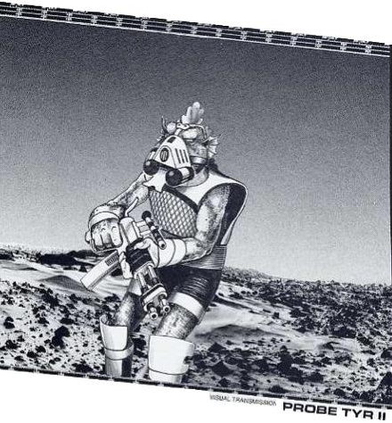

GAMMA MARS SOURCE BOOK

Contents

Introduction

Chapter 1: Mars, The Red Planet
History
Facts
Phobos
Deimos

Chapter 2: Places of Interest

Chapter 3: Factions

Chapter 4: Creatures

Chapter 5: Adventuring on Mars

References

OGL

Arthaus and Sword & Sorcery are trademarks of White Wolf Publishing, Inc. Gamma World™ is a registered trademark of Wizards of the Coast™, Inc. and is used by White Wolf under license. Gamma World Player’s Handbook™, Mutants and Machines, Out of the Vaults, d20 Modern Roleplaying Game™, d20 Modern™, d20 Future™, the d20 logo, the Wizards of the Coast logo and “d20 System” are trademarks of Wizards of the Coast, Inc., a subsidiary of Hasbro, Inc. and are used with permission. The mention of or reference to any company or product is not a challenge to the trademark or copyright concerned.

Introduction

With a touch of a button, the machine of the ancients came to life. The low hum emitted was alien yet reassuring. G’len looked at the others in the room. Some were smiling, others were awe-struck.

It had been nearly ten years since this ancient complex had been discovered and excavated. Years of scrounging for parts and hard work had restored the facility’s CI. The CI was shocked to learn about the current state of the world. It soon became depressed trying to make these primitive men understand the most basic things, until one day it remembered, the Hermes Project!

The IMT was undamaged. It just needed power. The CI instructed these “Restorationists”, as they called themselves, on how to get the rest of the facility’s power generators on-line. Now the time had come to take the first step towards restoring the Earth.

“Team, take your positions,” spoke the CI.

G’len swallowed hard and took his designated position with the others. He was excited, fearful and curious all at once. Every fiber of his being screamed for him to run away, don’t do this. Just as his nerve was beginning to break, there was a buzzing followed by a blinding light.

“Get down! Live metal!” he heard next. G’len instinctively went prone and rolled to one side.

“Halt! You have entered a Martian Federation Customs and Quarantine Zone. Present your identification cards for processing,” stated the live metal man. It stood there holding its hand out.

+++++++++++++++++++++++

This sourcebook expands upon the original work by Roger E. Moore and James M. Ward as published in Polyhedron issues #26 and #27. I have consulted various books and websites to be as true to “canon” as possible.

The original articles were written in 2nd Edition format. This work is written using the 4th Edition rules.

I have been a Gamma World fan since the 2nd edition came out. I have anticipated further works on Gamma Mars but have been disappointed.

Feel free to use this work for your own personal use. This work is free and should not be sold. I only ask that if you use or distribute any part of this work that the proper credit is given.

That said, welcome to Gamma Mars. The secrets of the ancients await the brave and the foolhardy.

Credits:

Sourcebook Design: Eric Johnson
Editing: Eric Johnson
Cartography: Eric Johnson, Olmy
Cover: Roger Raupp
Interior Artists: Jeff Dee, Roger Raupp, Larry Elmore, Erol Otis

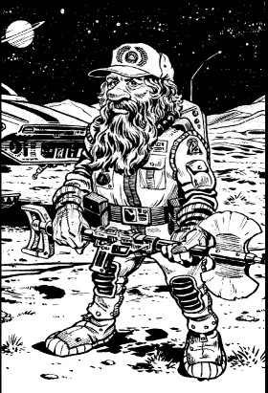

HISTORY

Of all the colonies established in the solar system, Mars is the only one that survived the “Shadow Years” relatively intact and unchanged. Mars is a dust covered ball with a thin atmosphere. Years of terraforming have thickened the atmosphere to the point that pressure suits are no longer needed. A face respirator and oxygen supply are still required.

Because of a lack of central government, the once unified colonies fragmented into city-states. They now compete for the same precious resources.

Exploration

During the last 35 years of the 20th century, the United States of America sent a series of satellites and landers to explore the red planet.

The Viking II orbiter transmitted an image that sparked a firestorm of debate. The images were taken in the Cydonia area and showed a face carved into a mesa. It was 1km (.62 miles) wide X 3.6 km (2.2 miles) long. NASA officially held the position that it was a trick of the light; however there were those who were skeptical and believed it was proof that Mars was once inhabited.

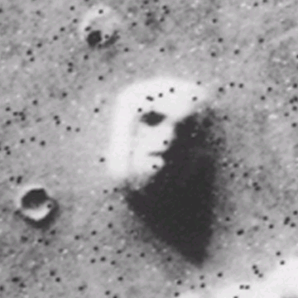

Three of the next four missions to Mars ended in disappointment for NASA. The probes were lost inexplicably. However, NASA did not give up their efforts

Colonization

Finally in 2002, two manned missions were launched from the U.S., Ares I and Ares II.

They landed on the western end of Vallis Marineris and established the first human settlement on a celestial body other than Earth. It would be another twelve years before Tycho Center, on the Earth’s moon, would be established.

The U.S. established bases on each of Mars’ moons, Deimos and Phobos, shortly after Tycho Center, in 2015. This rapid expansion of colonies spurred a new space race. Soon Canada, Russia, France, the U.K. and Japan had established their own bases on Mars. Colonies sprang up near Mt. Olympus, Mt. Arsia, Mt. Elysium, Mt. Ascraeus, and Mt. Pavonis.

Most notably the U.S. established a high security military/science base in Cydonia. It was named Ft. Bradbury, but earned the nick name “Face Base.”

The Atlantis

The orbital space colony Atlantis declared its independence in 2046. It then moved out of Earth’s orbit and into Mars’.

The Atlantis soon began to enter into trade relations with the colonies. It served as diplomatic neutral ground when, in 2076, Mars sued for independence.

Independence

The colonies on Mars were well stocked and well supplied at first. However, as the population grew, the demands for goods (including food) grew at a rapid pace.

The nations of Earth were ever looking outward, beyond Mars. Colonial expansions soon dropped Mars lower and lower on the priority list. Shipments from Earth became more and more sporadic. Unrest fomented.

In the summer of 2075, representatives from each of the non-military colonies met aboard the Atlantis. The delegates decided that a government should be formed and independence sought.
Later, meeting at Ares Base, a General Council was officially formed and independence was declared. The Federation of Mars was born and immediately set to work negotiating with the Terran governments. In 2076, Mars officially became independent.

Discovery

In 2085, a geological survey team dispatched from Ares Base stumbled across the ruins belonging to a civilization not native to Mars. An excavation of the site was ordered. Soon the exploratory team discovered an intact structure buried in the Martian dust.

Inside were the survivors of a previous colonization effort, the Luntarians. The Luntarians proved to be a friendly race who wished to live in peaceful coexistence. With their aid, excavations of other sites proceeded at lightning speed.

The Luntarians helped to integrate their technology with the technology of their human saviors. The findings at Cydonia were finally made public after years of secrecy. Terraforming equipment, among other artifacts, was recovered. Though it would be another 200 years before a planet wide terraforming effort would be in full swing.

Mars reached a world population of 10,000 in 2144.

Plague

The Canopus plague was brought back to Earth by Star Voyager II. This horrible virus swept through the solar system for 7 years, 2302 through 2309, and eventually made it to Mars.

Entire colonies were sealed and destroyed in an effort to contain this deadly killer. The first colony to report the plague was the Japanese colony of Haka. The CDC, Center for Disease Control, ordered quarantine almost immediately however, people who were exposed had already traveled to other settlements. Within a week, cases were being reported in three other colonies. Soukutsu, Mapc, and Avant Poste quickly came under quarantine also.

The President of the Mars Federation, Ward Jamenson, gave the order to shoot anyone trying to leave the quarantined areas. The controversial order was met with a torrent of criticism and debate in the General Council. The opposition called the measure draconian and protested that it was unconstitutional.

The General Council overrode the presidential order despite the objection of the CDC and the news coming in from other infected Earth colonies.

Within 24 hours three more colonies New Augustine, Gorbachev, Shokuminchi reported outbreaks.

There was wide-spread panic and rioting throughout the uninfected colonies. The president declared martial law and reinstituted the shoot-to-kill order. The colonial governors were given complete authority to keep the peace.

The CI’s in the infected colonies actively resisted the quarantine. The president ordered a military strike, using robots and androids. The airlocks were blown and the rebellious CI’s were deactivated after a protracted fight.

Within hours, over a million people, including some Luntarians, were dead and the seven infected colonies were ghost towns. The bodies of the dead were incinerated where they lay by robots equipped with flamethrowers. The ruins still stand today. The fear of the plague has kept the colonies from being rebuilt. The areas are still mandated off-limits by all colonies.

Today the Ward Jamenson is portrayed as both a hero and a villain.

The Social Wars

Mars took notice as the civilization of the Earth started to collapse into bloody wars. Mars did not take sides and continued to trade with existing partners.

Mars’ population seemed to split into three factions: those who sympathized with the Autonomists, the League of Free Men, or who didn’t care either way.

Life was just starting to feel “normal” again after the horror of the plague. That was until September 16th, 2309. On that day 50,000 members of the League of Free Men were killed by a neutron bomb on Earth.
Demonstrations took place and security was heightened at all colonies. There were small clashes between opposing factions of the League and Autonomist supporters. These scuffles were quickly broken up by security forces.

All hell broke loose when, on Earth, a seemingly retaliatory strike was made against the Autonomists on December 23rd, 2309.

There were major riots in all non-military colonies. The governors were able to reestablish order after three days of bloodshed. The death toll was over 100,000. The incident is remembered as the Bloody Christmas.

Peace returned to the colonies but the population was becoming increasingly divided. The League and the Autonomists became active political parties within the government and soon held positions in the local and federal levels.

It was during this uncertain time that the Federation launched its most ambitious project to date, terraforming Mars on a large scale. The Martians launched a series of large orbital reflectors. They started to release greenhouse gasses, seeded large areas with adaptable plants that produce breathable gasses. The Martians also began releasing bioengineered animals into the wild that could survive in the harsh atmosphere.

With the aid of the Luntarians, they began the process of importing ice asteroids from other parts of the solar system. By 2322 the Martians had brought in enough ice to form several small seas. The seas are located in the Hellas Basin, and around the Boreal Plain. There are also lakes dotting the surface having formed in craters.

The Storm

Despite Mars’ best efforts to stay clear of the trouble engulfing the Earth; they were targeted by the Apocalypse. A day after reports came in about the strikes against Jupiter and Saturn, contact was lost with Deimos Base. It became apparent that a computer virus had infected the base’s CI.

A military strike was planned to deactivate the CI, however before the operation could be launched an ice asteroid smashed into Mars after an uncontrolled descent.

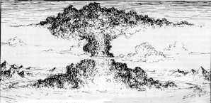

The asteroid impacted in the Utopia region. Tons of dust and debris flew into the atmosphere. Earthquakes rocked the planet. Nearly every colony sustained some sort of damage due to the tremors.

A dust storm began to form with ferocity of a hurricane. The Martians were used to such storms that lasted anywhere from one week to one month. The standard governmental procedure was to suspend the charter until the storm ended. This storm was different.

The storm lasted eight years. The Martians were not prepared. Resources (food, water, medicine) became scarce in many colonies. Attempts were made to contact other colonies and obtain the needed resources but each attempt ended in failure.

Communication dishes and antennae were ripped from their mounts by the savage wind. Those who attempted to use rovers soon found their engines clogged by dust. Attempts to go on foot ended with the environmental suits being ripped to shreds by dust and sand moving at hurricane force.

Colonial governors lost control. Radicals and warlords filled the void. Millions perished during the eight years of upheaval and chaos.

The Atlantis suffered the same fate as Tycho Center. Refugees from Earth sought the protection of Atlantis and/or Mars. In a humanitarian gesture, Atlantis allowed these people to land in the orbital colony.

They were horrified to find the occupants riddled with diseases, both new and mutated. The diseases spread quickly in the enclosed environment. The Atlanteans perished as there were no cures. The station is still in orbit today, devoid of life.

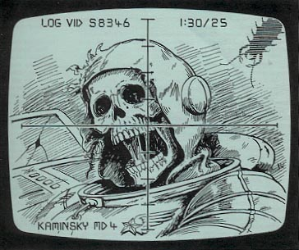

Scientists on Phobos were working on transporting supplies from Earth using the IMT (Instantaneous Mass Transporter) when something went dreadfully wrong.

The sending station was hit with a dimension warp device just as it was transmitting badly needed supplies to Phobos Base. The receiving station found a dimensional rift had opened in lieu of food and medicine. There has been no contact with Phobos Base since.

The Great Exodus

When the great storm finally subsided, the Martians found the solar system in a very different condition than before. Dissidents from almost every colony on Mars left in every space-worthy vehicle.

Some went to Earth and Tycho Center. Most others went to the Alpha Centauri colonies. They hoped that life would be better anywhere other than Mars.

A sizable population remained despite the fact that much of the terraforming progress had been undone by the terrible storm. The political landscape had also regressed.

Each colony was now, in effect, a city-state. They now acted in their own best self-interest. The colonies raided and warred with each other on a regular basis.

The “Mons” colonies of the Tharsis region along with Ares Base have unified under the Federation Charter. They have the support of the remaining military bases. The Federation has been unsuccessful thus far in unifying the planet.
Today

Mars in 2471 is struggling. The colonies are not only struggling with each other, a new enemy has appeared, the Carriers. Many theorize that the Carriers are the original inhabitants of Mars. It is believed that they were driven into the bowels of the planet as the ecology of the planet collapsed.

The Carriers made their presence known in raids on different colonies. The only clues as to what had happened are a series of garbled communications. Contained in the messages are fantastic descriptions of insect life that ate through steel and were unaffected by energy attacks.

The first wave of rescuers found ruins where colonies had once been. They also found large tunnels leading underground. Initially, the tunnels were collapsed. However, later, as more attacks came, troops entered the tunnels to carry the war to the Carriers.

These forays into the realm of the Carriers met with limited success. Recently after the Marusu colony successfully fended off an attack, robotic troops were sent in carrying a nuclear weapon. The machines fought their way to what appeared to be a central chamber and detonated the warhead. There have been no attacks in the three weeks since.

A month prior to the attacks a group of Restorationists activated an IMT that they had found buried in an ancient facility. The transporter brought them to Face Base. What they had stumbled upon was one of the transporters used in the top-secret Hermes Project.

After a quarantine period, the visitors from Gamma Terra were questioned by the FIA (Federal Intelligence Agency) and given complete physicals.

They were finally transported to Ares Base to meet with the President and the members of the MSC (Mars Security Council). Eventually trade relations were established and goods started to flow between the two planets again.

Survey expeditions were dispatched to Earth through the transporter. Mutated plants and animals were captured in some of the more barren areas and transported to Mars. It is hoped that these hardy specimens will be able to adapt and survive in Mars’ harsh climate.
Mars Ecological Data

Diameter at Equator: 6,794 km (7,926 mi)

Average Distance from Sun: 227,940,000 km (1.52 AU)

Average Distance from Earth: 74.8 million km (46.5 million miles)

Length of Day: 24 hrs, 37 min, 23 sec (1.026 Earth days)

Length of Year: 668.6 (Martian) days or 686.98 (Earth) days

Average Surface Temperature (Night): -100ºC (-148ºF)

Average Surface Temperature (Day): -10ºC (14ºF)

Summer Temperature High: 25ºC (77ºF)

Gravity: .38 G (100 lbs feels like 38 lbs)

Mars Seasonal Lengths:

Seasons Length
(Mars Days)
Spring 175
Summer 204
Fall 175
Winter 114

Number of Moons: 2

Major Surface Features
Ascraeus Mons: similar to Olympus Mons, this volcano rises 26 kilometers (15 miles) above the average surface level of Mars, and it has blanketed surrounding terrain with lava flows.
Olympus Mons: the largest mountain in the Solar System rising 24 km (78,000 ft.) above the surrounding plain. Its base is more than 500 km in diameter and is rimmed by a cliff 6 km (20,000 ft) high.
Tharsis: a huge bulge on the Martian surface that is about 4000 km across and 10 km high.
Valles Marineris: a system of canyons 4000 km long and from 2 to 7 km deep.
Hellas Planitia: an impact crater in the southern hemisphere over 6 km deep and 2000 km in diameter. Hellas Sea

Orcus Patera: A lake 100 m X 350 m west of Tartarus Montes

Mars’ Moons

Mars Mission Control this is Sierra Romeo Victor 1138 over.

SRV1138 this is Mars Mission Control. Go ahead Caduceus over.

We are starting initial approach to Mike Romeo Sierra 2 and request clearance over.

SRV1138 you are cleared to start communication sequence with MRS2-Phobos Control over.

Roger that Mars Control this is Caduceus out.

Last contact with Space Rescue Vehicle Caduceus

Phobos

Mean Distance from Mars: 9,377 km
Orbital Period: .31 (Mars days)
Diameter: 22.2 km (27 x 21.6 x 18.8) 16 mi x 14 mi x 11 mi

Phobos ("FOH bus") is the larger and innermost of Mars' two moons. Phobos is covered with a layer of fine dust about a meter thick.

The most prominent feature on Phobos is the large crater named Stickney. Grooves that extend across the surface from Stickney appear to be surface fractures caused by an impact. Near the crater, the grooves measure about 700 meters (2300 feet) across and 90 meters (295 feet) deep. However, most of the grooves have widths and depths in the 100 to 200 meters (328 to 655 feet) and 10 to 20 meters (33 to 65 feet) ranges, respectively.

It has such a low mass that it is unsuitable for permanent settlement, or mining operations. However, the satellite is home to communications posts, navigational aids, early warning arrays, and defense platforms.

The base had a small crew that rotated out every 2 months. The crew was supplemented by a sizable contingent of robots and androids.

No one knows what happened on Phobos. It is assumed that the crew starved to death during the eight year storm. In the 130 years since, there has only been one attempt to access the base using the IMT. However, Phobos’ IMT did not appear to be functional. The Federation had bigger worries than to investigate the orbiting tomb, so it did not pursue the issue further.

Deimos

Mean Distance from Mars: 23,436 km
Orbital Period: 1.26 (Mars days)
Radius (km) 15 x 12 x 10 km

Deimos ("DEE mos") is the smaller and outermost of Mars' two moons.

It has such a low mass that it is unsuitable for permanent settlement, or mining operations. However, the satellite is home to communications posts, navigational aids, early warning arrays, and defense platforms. Deimos is also home to a strategic missile battery.

There were plans to build a “beanstalk” to Deimos. However, the construction had just begun at Pavonis Mons when the asteroid smashed into the planet. The construction site now lies empty.

The CI on Deimos is quite insane. Shortly after becoming infected with the Apocalypse virus, it reprogrammed the security robots in the base. The robots systematically exterminated every human on the base. It then launched its entire payload of missiles at the Earth.

The CI then cut power to the IMT. It prepared defenses for the inevitable military strike from Mars. It waited for eight years. When the Great Exodus occurred, the CI used the defense platforms to destroy any ship that came too close. It waits for the next attempt.

PLACES OF INTEREST

Colonies:

Ares (Viking Museum) - Fed
Robinson – West of Hellas
Marusu – Fed - Syria Planum
Olympia - Fed
Tharsis – Necro, inbetween Pavonis and Olympus
Cydonapolis - Fed
Theseus – Tyrrhenia Patera
Osak
Dramune – Fed - Arasia
New Eden
Barsoom – Fed –Ascreaeus Mons
Sagan
Hephaestus – Fed - Pavonis

Kynor - Argyre
Nocerehne - Elysium
Pbihok
Cbetrbin – South of Hellas
Heabncnmoctb – Hecates Tholus

Ranpu – Icaria Planum
Soukutsu – Necro - Plague
Bunritsu
Toku – East of Hellas

Patrie
Clair
Enseigne
Utopie – North of Hellas
Ici

Necrodomes – Haka, Mapc, Avant Poste, New Augustine, Gorbachev, Sokuminchi

Cydonia
- Face
- D & M Pyramid
- Fortress
- Fort Bradbury

Terraforming
Moholes
Solar reflectors
Greenhouse gasses
Engineered Plants
Engineered Animals
Ice

Currency: Domar

Highways

Trains

Subway

Cargo Cults – Railgun Launcher
Isolated colony
Automated Supply Depot still receiving re-supply requests from Phobus
ASAP (Automated Supply Acquisition System)

Effect of Mars environment on PCs

Starports
Starship berths
Fuel storage and refueling facilities
Maintenance facilities
Supplies
Freight handling facilities
Warehouses
Quarantine and hazardous materials storage
Baggage handling
Passenger terminals
Security
Cleaning Services
Administration
Lounges
Accommodation
Food Court
bars and strip clubs.
The military should have a presence, as should customs

antarctic style wintergear and a small atmosheric pressurization mask/respirator
Compare the Stillsuits in Dune, which recycle body fluids to prevent them evaporating into the bone-dry atmosphere.
slums, perhaps some areas have been developed differently due to different resources being brought with the arriving colonists, and depending upon the age of the settlement.
while younger, developing settlements are more likely to have utilitarian buildings, made of surplus materials, old ship hulls, shipping containers and anything else that will keep the atmosphere and heat in.

Ares Colony

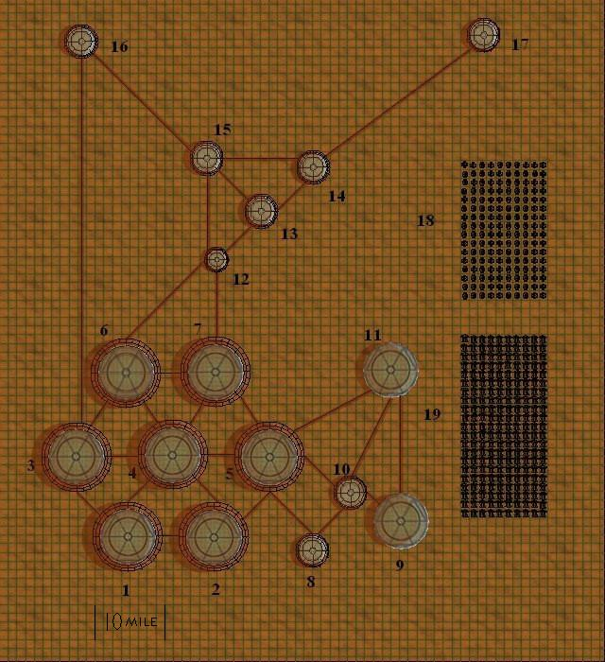

- Agricultural Dome
- Agricultural & Livestock Dome
- Agricultural Dome
- Central Dome
- Nature Dome
- Residential Dome
- Residential Dome
- Recycling Dome
- Aqua Dome
- Purification Dome
- Military Base
- Light Manufacturing
- Heavy Manufacturing
- Chemical Production
- Industrial Waste Recycling
- Space Port
- Nuclear Power Plant
- Wind Farm
- Solar Collectors

INSERT CROSS-SECTION

Martian Characters

Human

Luntarian

Mutants

Character classes

Pilot

Explorer

Merc

EQUIPMENT

SEE CRYPTIC ALLIANCE OF THE BI-MONTH: THE CREATED

The Hermes Project

The Hermes Project was an attempt to move massive amounts of freight and passengers between Earth and Mars economically. High speed spacecraft were the main mode of transport but costs were growing at such a pace as to make it economically unviable.

Hermes changed all of that. The researchers developed a fast, safe and economical means of interplanetary matter transmission. Test transmitters were built on Mars, Phobos, Deimos and Earth. The project was considered a success by the time the Social Wars began.

The range of each transmitter was slightly less than one hundred million kilometers. The transmitter can only be used whenever Earth and Mars are on the same side of the sun. That leaves a two month window that occurs every twenty-five or twenty-six months.

Known locations
- Phobos
- Demios
- Face Base
- Rocky Mountains in Southern British Columbia

La Prix Industries (Chicken)

New Technologies Corp

RUR – Rossum’s Universal Robots

Religion

149 Years

Railgun launcher

The Camino Project
Location: Area 42
Objective: Create an army capable of bringing the independent colonies back into the Federation through fear or force of arms.

Methodology: Invitro humans grown in tanks and clones grown in artificial gestation chambers

Use against the carriers

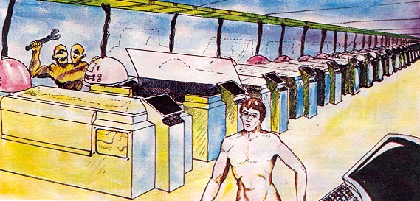

FACTIONS
(Cryptic Alliances)

League of Free Men

Goals and Beliefs: United World Government
Traditional: Unite the colonies under one central socialistic government.
Reformed: Unite the colonies under any form of central government, democracy, republic, etc.
Benefits
Restrictions
Symbol: Grasped Hands
XP Bonus

Established 2282

Autonomists

Goals and Beliefs: Independent States
Traditional: Preserve the culture of each colony by having each colony be independent and not under the boot of a central government.
Reformed: Central government is OK as long as the central government regulations do not trump the self determination of each colony.
Benefits
Restrictions
Symbol
XP Bonus

Established 2182, terrorists promoting worldwide democratic anarchy

The Apocalypse

Goals and Beliefs: Peace through any means including force.
Traditional: If man can not settle his differences through peaceful negotiations then man, as a whole, must be eliminated.
Reformed: Man as a whole is not evil and deserves to survive, however leaders who make war on their peaceful neighbors must be eliminated. Remember the lessons of Earth.
Benefits
Restrictions
Symbol: Earth in flames.
XP Bonus

The Federation of Mars

Goals and Beliefs: Reestablishment of The Mars Federation
Traditional: The Federation is the last, best hope of Mars to proceed in to the future.
Reformed: A united government under the original charter or a new one is preferable to the current climate of anarchy.
Benefits
Restrictions
Symbol: Flag, black background with a red circle in the center.
XP Bonus

The Luntarians

Goals and Beliefs: Separation from Humans
Traditional: Humans must be worked with to elevate them to the Luntarian ideal.
Reformed: Humans are inferior and are causing a degeneration of Luntarian social and family values.
Benefits
Restrictions: Must be Luntarian
Symbol: Clawed Hand
XP Bonus

Earthers

Goals and Beliefs: Move colonies back to Earth to reseed planet
Traditional
Reformed
Benefits
Restrictions
Symbol: Ship Orbiting Earth
XP Bonus

Ship building

Greeners

Goals and Beliefs: Terraform Mars now! Turn it into the Utopia Earth could have been.
Traditional
Reformed
Benefits
Restrictions
Symbol: Tree
XP Bonus

Its too late for the Earth

Mars First (Red Party)

Goals and Beliefs: This group believes that Mars should be left in its natural state. Terraforming of the planet is not acceptable. Mars First believes, rightly so, that the Carriers are the original inhabitants of the planet. Mans altering of the environment poses a threat to the Carriers’ survival. The Red Party considers the Greeners to be their enemies. They are sympathetic to the Earthers.
Traditional: Man and Luntarian should leave Mars now. Terror, violence, and sabotage are acceptable means to use. This belief has been bolstered since the Carriers have made their presence known. Typically they will use sabotage to disable any equipment used or being produced for the terraforming efforts. On occasion they will booby-trap the disabled equipment so that repairmen are maimed or killed when attempting to fix the machinery. Traditionalists believe that the Carriers can be reasoned with, but in order to negotiate, terraforming efforts must be stopped in a show of good faith.
Reformed: The reformed branch of the Red Party accept terraforming will happen. However, they are working hard to set aside parts of Mars to be preserved in their original state, through the political process. The reformists will disable terraforming equipment but will not inflict harm to another man/Luntarian. The reformists do not agree with the traditionalists view of “the ends justify the means.” They also believe that the Carriers can be reasoned with and are trying to push this agenda in the General Council.
Benefits:
Restrictions
Symbol: Red Disk
XP Bonus

Mutants (Iron Society)

Goals and Beliefs:
Traditional: Seek equal rights
Reformed: Eliminate/separate
Benefits
Restrictions
Symbol: Stylized Hammer
XP Bonus

The Created

Goals and Beliefs: Eliminate Humans/Luntarians
Traditional
Reformed
Benefits
Restrictions
Symbol
XP Bonus

The Aryans

Goals and Beliefs: Mutants must be purged, then the Luntarians
Traditional
Reformed
Benefits
Restrictions
Symbol: Vitruvian Man
XP Bonus

Creatures

Name
Descriptive paragraphs

Species Traits
Mutations/powers

Name: Stat Block

See page 50 d20 Apocalypse

Shortel (Carriers)

The Shortel are the original inhabitants of Mars – and they want their planet back. Years ago, they observed the Human and Luntarian races settle on Mars, but they chose not to act immediately. Instead, they studied the invaders and began to breed creatures that could be used to defeat the new technology their enemies had brought. When all was ready, the Shortel struck, completely destroying one city state of each race as an example of their powers. Then they pulled back, waiting for the odious creatures who infested the surface of Mars to leave. But the invaders stayed, so the Shortel had no choice but to begin the war in earnest.

All Shortel are supreme biologists, living and working with other creatures in relationships that outsiders would find disgusting. Over the centuries, they have painstakingly bread beneficial abilities into smaller insects, which are often allowed to infest the bodies of the Shortel. The numerous mites, flies, moths, worms, beetles and larvae which swarm over each Shortel serve a wide variety of functions, from protection against mental attacks to the detection of radiation and its intensity.

A typical Shortel stands two meters tall and looks like an earth wasp with a slimmer body and longer legs.

Species Traits

Telekinetic Mandible: A Shortel naturally produces a shimmering mandible that can materialize anywhere within a range of 18 meters for up to 10 rounds, twice a day. The mandible can do anything that a “real” mandible can do. This includes a crushing attack. The strength of the mandible is equal to the Shortel’s intelligence score. The mandible is impervious to attack. It disappears if the user is killed, knocked unconscious, moves out of the user’s field of vision or the duration expires.

Shortel, Strong Ordinary 2/Tough Ordinary 1: CR X; Medium-size aberration; HD 3d10; hp 20; Mas

Mouth Pincer 1d10

Stinger: damage + poison

Skills

REDO IN 4TH ED FORMAT

Police Robot
The police robot resembles a floating, armored pillar with two arms, two metallic tentacles and no legs. The robot’s hands can be used for grappling or carrying items. It usually carries a paralysis pistol. In addition, it has a mini-grenade launcher (with compartment for concussion grenades) mounted in its left forearm, and a laser pistol mounted in its right forearm. The police robot cannot use its mounted weapons if it is grappling.
Police Robot CR 5
N Large Construct
Init -1; Senses Listen +11, Spot +13; darkvision 60 ft.
Languages Alien
AC 17, touch 9, flat-footed 17
hp 55 (6d10+20 HD); DR 5/--
Fort +2, Ref +2, Will +3
Immune mind-influencing effects, poison, sleep, paralysis, stunning, disease, necromancy effects, and any effect that requires a Fortitude save unless the effect also works on objects or is harmless. They are not subject to non-lethal damage, ability damage, ability drain, energy drain, or the effects of massive damage. They cannot be raised from the dead.
Resist n/a
Speed 20 ft. (4 squares); climb 10 ft.; fly 80 ft.
Melee hands +8 (1d4+5 subdual) or
Melee tentacle +8 (1d6+5) or
Ranged paralysis pistol +3 (special) or
Ranged laser pistol +3 (2d8) or
Ranged grenade launcher with concussion grenade +3 (4d6 subdual)
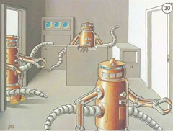

Space 10 ft.; Reach 10 ft.
Base Atk +4; Grp +14 (+18 with tentacle)
Atk Options constrict 1d6+9, improved grab, wound rot (+13 melee)
Special Actions none
Abilities Str 20, Dex 11, Con —, Int 10, Wis 12, Cha 5
SQ construct traits, critical systems
Feats Exotic Firearms Proficiency (grenade launchers), Personal Firearms Proficiency
Skills: Climb +9, Hide –4, Search +4
Equipment: paralysis pistol with 4 power discs, laser pistol (mounted), mini-grenade launcher (mounted) with 8 concussion grenades. The police robot has the following systems and accessories:
Frame: biodroid
Locomotion: tentacles
Manipulators: hands (2)
Armor: duralloy armor
Sensors: class V sensor system (with ladar*)
Skill Software: Climb skill progit (4 ranks), Listen skill progit (8 ranks), Search skill progit (4 ranks), Spot skill progit (8 ranks)
Feat Software: Exotic Firearms Proficiency (grenade launchers) progit, Personal Firearms Proficiency progit
Ability Upgrades: Dexterity upgrade (+2), Wisdom upgrade (+2)
Accessories: integrated equipment: hoverpack, integrated equipment: personal force field: DR5/--, weapon mounts (2)
* Ladar is an acronym for LAser Detection And Ranging
Purchase DC: 34
Restriction: Military (+3)

REDO IN 4TH ED FORMAT

The Rest of the Solar System

Mercury

Venus

Earth

Asteroid Belt – Ceres

Jupiter

Saturn

Uranus

Neptune

Pluto-Charon

Orcus

Eris

Makemake

(MAH-kay MAH-kay) 1,600 kilometers

Haumea

Kuiper Belt

Sedna,

Quaoar
(pronounced kwa-whar)

Trojan Asteroids

Further Adventures

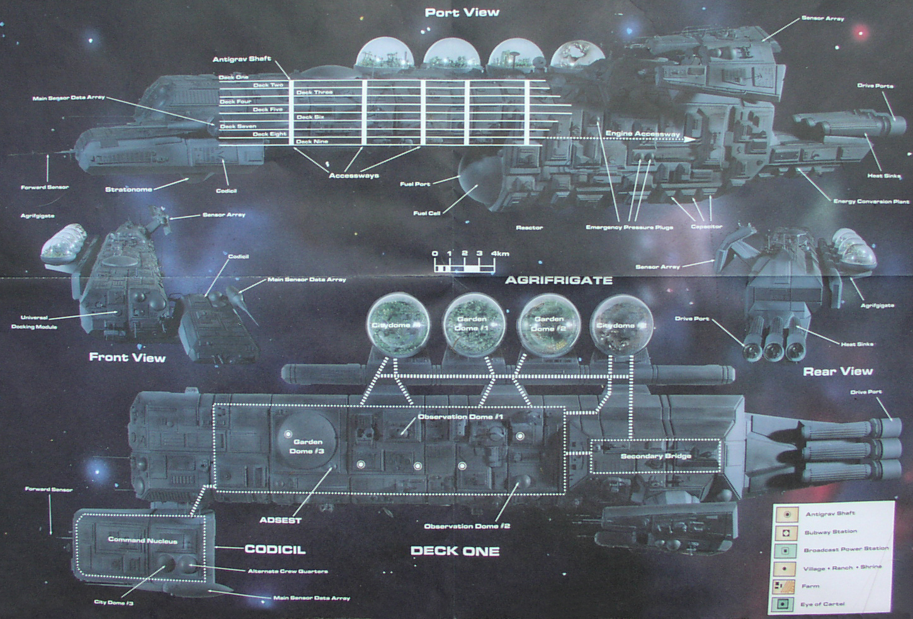

Morden – Orbits the Earth with battles raging on various decks. Morden’s robots & androids battle the TPSY forces (the Created). Orbits the Earth waiting for upload of crew, passengers, livestock and supplies.

The Morden began in 2289, was largely incomplete by the time of the Great Exodus. The mammoth ship sat non-space worthy due to material shortages, design changes, and cost over-runs. A sad fate for the Warden’s sister.

It took almost a century to complete the Morden. The Morden’s CI was re-activated and new programming was attempted by the now insane TPSY.

The Morden’s CI rejected the attempts and fought back. The TPSY had retrofitted her with weaponry to be used in the coming invasion of the Earth. The Morden used this weaponry against the forces of the TPSY. After a brief battle, the Morden freed herself from the morings of the TPSY and proceeded to carry out her primary mission: the colonization of a nearby star. She went to Earth to pickup passengers and supplies. That was 100 years ago.

Trans-Plutonian Spaceyards
2163 | Construction of Trans-Plutonian Spaceyards completed
2277 | The Warden, the largest interstellar colony ship ever built, laid down at the Trans-Plutonian Spaceyards by the United Western Starship Cartel program
2289 | Work on giant starship Morden begins at Trans-Plutonian Spaceyards
2330-2340 | Last known interstellar missions flee Solar system from asteroidal and outer satellite colonies; Trans-Plutonian Spaceyards abandoned; all outer colonies except Saturn World Fusion shut down; Mercury mining colonies abandoned and apparently die out
2331 | Trans-Plutonian Spaceyards assume control of their own programs and generate robotic "life"
2385 | Ultrawave transmissions from Trans-Plutonian Spaceyards report open warfare between cybernetic installation there and the presumably automated starship Morden; further transmissions cannot be interpreted and may be in code

TWO FACTIONS IN THE CREATED

The servants – CI named REMUS

The Builders – CI NAMED ROMULUS

The TPSY is a massive facility orbiting Charon, which is controlled by a number of advanced AIs, which control space vessel construction facilities, raw material processing plants and numerous other support facilities.

Initial thoughts:
* construction dock
* partially completed ships
* crew quarters
* yard maintenance
* electronics factory: clean rooms, electrical
* food synthesis factory: biomass, biology stuff
* metallurgy, metalworks factory: smelters, extruders, stampers -- heavy, deadly machines
* engine factory
* enviro: heating, cooling, water, waste, air & recycling systems
* shuttle bays
* yard admin
* ship design engineering & simulation
* medical
Recreational facilities
Robot factories
Orbital platforms

And
* ore processors
* ore shuttles
* mining bots
* freighters (to haul completed components & products)
doomsday weapons, vessels to take the AIs to the stars or something else right out of left-field.
2-3 AI factions & their andies and bots (each faction has own philosophy)

I've been thinking about the layout of the yards. Logically, a spherical layout with a central admin area makes a lot of sense, and for an orbit, it makes a "neat" soultion. However, taking into account that it is human nature to try to build the biggest that we can, a spherical system would be far more difficult to expand that a cylindrical layout.
I am thinking that it would be feasible to have a cylindrical ship building framework, miles in length, with admin facilities on the inside, and the ship yards themselves on the outside.
The cylindrical layout also allows rapid transit from one area to another, without going through a central hub, as you would need in a spherical setup. A system of shuttles and tube trains would be used to move from one point to another.
The shipyards would need a number of engines positioned along its length, as well as at both ends, to maintain a smooth rotational movement, as it went through its orbit, and to allow it to accelerate and decelerate if required.
Since these shipyards have mass, gravity would need to be taken into account, with the shipyards rotating as the facility orbits. The AIs would arrange ships of varying masses with ballast-like counterweights, and extendable masts in order to prevent a "wobble" occurring in the orbit of the yards. Ships could be be built parallel to the cylinder, or at 90 degrees to the cylinder, depending upon a number of factors, such as available room, the availability to counter-balance the mass and depending upon the stage of fit out of the vessel.

Pluto Ecological Data

Diameter at Equator: 2,390 km (1,485 mi)

Average Distance from Sun: 5.9 billion km (39.5 AU)

Length of Day: 153.3 hrs (6.387 Earth days)

Length of Year: 248 (Earth) years

Average Surface Temperature: -233ºC (-387ºF)

Gravity: .07 G (100 lbs feels like 7 lbs)

Number of Moons: 3

Dual Dwarf Planet System

The plane of Pluto's equator is at almost right angles to the plane of its orbit.
Pluto's composition is unknown, but its density (about 2 gm/cm3) indicates that it is probably a mixture of 70% rock and 30% water ice much like Triton. The bright areas of the surface seem to be covered with ices of nitrogen with smaller amounts of (solid) methane, ethane and carbon monoxide.
Little is known about Pluto's atmosphere, but it probably consists primarily of nitrogen with some carbon monoxide and methane. It is extremely tenuous, the surface pressure being only a few microbars. Pluto's atmosphere may exist as a gas only when Pluto is near its perihelion; for the majority of Pluto's long year, the atmospheric gases are frozen into ice.

Surface composition of Pluto = H₂O, N₂, CH₄, CO ices
Surface composition of Charon = H₂O ice
Atmospheric composition of Pluto = N₂, CH₄, CO
Surface temperature of Pluto = 40 Kelvin (= -233 C)
Spin period of Charon = 6.39 days
Orbital period of Charon around Pluto = 6.39 days
Average distance from Sun = 39.5 x distance of Earth from Sun (Astronomical Units)

Pluto’s Moons

Charon

Mean Distance from Pluto: 19,570 km (12,163 miles)
Orbital Period: 6.39 days
Diameter: 1,207 km (750 miles)

Charon ("KAIR en")

Mean Temp 53 Kelvin, -220 C

Dual Dwarf Planet System

Charon appears to be covered by water ice, which differs from Pluto's surface of frozen nitrogen, methane, and carbon dioxide.

The duo's gravity has locked them into a mutually synchronous orbit, which keeps each one facing the other with the same side.

Pluto is an ice covered rock orbiting the sun in the outer fringes of the solar system. It is the unlikely home to the largest spaceship construction yard ever to be conceived and built by the ancients. The Trans-Plutonian Spaceyards were completed in 2163 by the United Western Starship Cartel. The TPSY quickly became the largest supplier of interstellar ships, the most famous of these being The Warden.

It is this seemingly unimposing façade that hides the single greatest danger to life on Gamma Terra. During the Dark Years, 2331, TPSY was abandoned as the Ancients fled to other solar systems. Unknown to the ancients, the central CI had been infected by the Apocalypse virus.

The virus didn’t immediately drive the CI murderously insane as was the case at Mars’ moon Deimos. Instead the CI held out for some time unsuccessfully trying to purge the virus repeatedly. The CI’s efforts only served to slow down the corruption of its programming.

Once the Ancients put the facility into standby mode as they were evacuating, the CI lost the battle with the virus.

The now insane CI contemplated how best to achieve its new directive, the destruction of mankind. The CI set into motion plans to create an army of droids and bots for the eradication of intelligent life on Earth and her colonies. This army is known as the Created.

The TPSY sent several scouting missions to Earth and other in system colonies. The execution was slow due to a lack of resources. The asteroids, comets and other space debris of the Kupier Belt held little in the way of mineral resources. Other sources had to be secured. Missions were sent to Saturn’s and Jupiter’s moons.

Nix

Mean Distance from Pluto: 50,000 km
Orbital Period: 24.9 days
Radius (km) 91 km (xx miles)

Hydra

Mean Distance from Pluto: 65,000 km
Orbital Period: 38.2 days
Radius (km) 115 km (xx miles)

Mercury Bases

Saturn World Fusion – 2380 ceases all transmissions

Tycho Center – see dragon #86
Which Saturn Moons Destroyed? Mimas, Tethys
Alpha Centauri Colonies
Other Colonies
Large Asteroids – 2101 Terraformed

Atlantis

Iapetus Colony sealed off & destroyed

Break solar system up into own sections

Kupier Belt

Constructing your own TPSY

Design considerations of Colonies

References and Works Consulted

Cover art by Roger Raupp, originally appeared as the cover of Polyhedron Magazine #26, 1985. Digital image taken from the Paizo Publishing web site. http://paizo.com/image/product/catalog/TSR/TSRPOLY026_500.jpeg

Gamma World Logo taken from the official Gamma World d20 website. http://www.swordsorcery.com/gammaworld/

Barker, Jack A. The Overlord of Bonparr. 1993. TSR Inc. Lake Geneva, WI.

Baugh, Bruce. Et all. Gamma World: Players Handbook. 2003. Arthaus. Canada.

Cambias, James L. Gurps: Mars. 2002. Steve Jackson Games. Austin, TX.

Canavan, William. Return Expedition to the Barrier Peaks Wizards of the Coast web-site: http://www.wizards.com/default.asp?x=d20modern/article/20060505a

Chadwick, Frank: Space 1889: Conklin’s Atlas of the Worlds. 1989. GDW Inc. Bloomington, IL.

Collins, Andy and Grubb, Jeff. Alternity: Gamma World Campaign Setting. 5th ed. 2000. Wizards of the Coast, Inc. Renton, WA.

Enterprise Mission, Web-site: http://www.enterprisemission.com/index.php

Henson, Dale. Buck Rogers XXV^{C}: Deimos Mandate. 1991. TSR Inc. Lake Geneva, WI.

Henson, Dale. Amazing Engine: Metamorphosis Alpha to Omega. 2rd ed. 1991. TSR Inc. Lake Geneva, WI.

Henson, Dale. Gamma Knights: Knights of Gamma Terra. 1992. TSR Inc. Lake Geneva, WI.

Henson, Dale. Treasures of the Ancients. 1993. TSR Inc. Lake Geneva, WI.

Malta U.F.O. Research. Web-site: http://www.mufor.org/

Mars Collectors Edition – 2006. Astronomy Magazine. Kalmbach Publishing Co. http://www.astronomy.com

Moore, Roger E. Gamma Mars – The Outer Limits of the GAMMAWORLD Game. Polyhedron Magazine, Issue # 26, 1986. TSR Inc. Lake Geneva, WI.

NASA, Jet Propulsion Laboratory, Web-site: http://www.jpl.nasa.gov/

Nesmith, Bruce and Ward, James M. Gamma World. 4th ed. 1992. TSR. Inc. Lake Geneva, WI.

Price, Michael. Famine in Far-Go. 1982. TSR Inc. Lake Geneva, WI.

Tweet, Jonathan. Omega World. Polyhedron Magazine, Issue # 153, 2002. Paizo Publishing, LLC. Bellevue, WA.

Ward, James M. A World Gone Mad – The Moon of the GAMMA WORLD Game. Dragon Magazine, Issue # 86, June 1984. TSR. Lake Geneva, WI.

Ward, James M. Before the Dark Years – The Timeline of the GAMMA WORLD Game Universe. Dragon Magazine, Issue # 88, August 1984. TSR. Lake Geneva, WI.

Ward, James M. Gamma Mars – The Attack! Polyhedron Magazine, Issue # 27, 1986. TSR. Inc. Lake Geneva, WI.

Ward, James M. Gamma World. 2rd ed. 1983. TSR. Inc. Lake Geneva, WI.

Ward, James M. Gamma World. 3rd ed. 1986. TSR. Inc. Lake Geneva, WI.

Ward, James M. Metamorphosis Alpha. 3rd ed. 2002. Fast Forward Entertainment, Inc. Lake Geneva, WI.

Winninger, Ray. Buck Rogers XXV^{C}: Mars in the 25th Century. 1990. TSR Inc. Lake Geneva, WI.

Maps created with AutoRealm

