Section VIII. Criminals


Crime as a Profession

As professions go, being a criminal does not convey the normal sorts of advantages that a legal career provides nor can such a person learn new skills at a school or through a hypno-training program. Instead, most underworld skills are learned on the streets.
Characters in normal professions can “go rotten,” but only the criminal can pick up certain skills at a professional cost, such as Hiding in Plain Sight. Others can learn these skills at the nonprofessional skill advancement rate. These skills can only be learned through practice.
The knowledge of criminal skills is not illegal, but using most of these skills are highly so. Standard pay rates do not apply with criminals. The cost to hire someone with these skill sets are generally negotiated discretely and off the books.
Note, this “profession” does not cover murderers, rapists, petty thieves and the like, but it does cover the professional thief, the cat-burglar, the confidence artist, terrorists and the headhunter/ bounty hunter. Space pirates will be covered in a different category
Like characters in other professions, a criminal starts off with 20 experience points, 10 of which are spent to become a criminal.
Criminal Archetypes
The eight Criminal “occupations” are: Cat Burglar, Confidence Artist, Fence, Headhunter, Manager, Pickpocket, Safecracker and Terrorist. These “vocations” include ten level 1 skills (or the equivalent of 10 skills) for the cost of only 8 experience points, leaving 2 experience points left over for the character to improve an existing skill or buy another one. Of course, the player is free to design their characters differently without the benefits of a starting career.
Cat Burglar. You’re not just the run of the mill burglar or the strong-armed thug who invades occupied homes. Instead, you’re stealthy and take pride in being able to gain undetected entry into buildings, taking what you want and leaving unnoticed.
This character gets Agility, normally a Techex skill, as a starting skill. Agility provides 7 points that can be split between Dexterity and Reaction Speed. Additional skills include: Alertness, Appraisals 1, Climbing, Security Systems: Basic 2, Security Systems: Advanced 1, Stealth 1, Street Skills 1 and Street Smarts 1.
Confidence Artist. Also called a con artist or trickster or swindler, you defraud a person or group by using “confidence games” – also called scams, schemes, stratagems or just “cons.” You work to gain a target’s trust by exploiting his compassion, credulity, dishonesty, greed, irresponsibility, naiveté or vanity. Then you need to slip away before your victim(s) catch on.
The con artist gets Charisma, as a starting skill, which provides 7 points that can be split between Personality and Leadership. Additional skills include: Bluff/Haggle 1, Disguise, Dramatics/Rhetoric, Empathetic Understanding 1, Etiquette, Persuasion 1, Spot a Mark 1, Street Skills 1, Street Smarts 1 and Swindle 1.
Fence. A fence is an individual who knowingly buys stolen property for later resale, sometimes in a legitimate market. The fence thus acts as a middleman between thieves and the eventual buyers of stolen goods who may not be aware that the goods are stolen. The fence is able to make a profit with stolen merchandise because he/she is able to pay thieves a very low price for stolen goods.
The fence starts with Intelligence, which provides 7 points that can be split between Intuition and Logic. Additional skills include: Appraisals 1, Bluff/Haggle 1, Business Administration 1, Computers: Basic 1, Fine Arts 1, Gemology 1, Persuasion 1, Street Skills 1, Street Smarts 1 and Underclass 1.
Headhunter. Also called a bounty hunter or contract killer, this is one dangerous character. Some more experienced headhunters will learn medical skills, ballistics and forensic medicine (at the nonprofessional skill cost) in order to better use poisons and freeze fields, as well as some combat skills to deal with threats. When a headhunter has the Investigation skill combined with Medical Treatment: Basic and Medical Treatment: Poisons and Radiation, they may be able to administer untraceable drugs and poisons.
This character starts off with Endurance, which provides 7 points that can be split between Strength and Stamina. Additional skills include: Alertness, Hide in Plain Sight 1, Street Skills 1, Street Smarts 1, Investigation 1, Law 1 and Whitewash 1. With the remaining 2 experience points, the Headhunter must purchase Martial Arts or Melee (level 1) plus a ranged weapon skill such as Beam or P.G.S.

Manager. This is a minor crime boss with a goal of becoming a major underworld leader. As a manager, he usually does not get involved in dangerous operations. Other than a few enforcers working directly under him, many people in his crime syndicate may not even know his true identity or whereabouts.
A manager starts off with a skill called Acumen which provides 7 points that can be split between Leadership and Logic. Additional skills include: Analyze Social System, Business Administration 2, Law 1, Management, Money Laundering 1, Persuasion 1, Street Skills 1 and Street Smarts 1.
Pickpocket. Pilfering items is what you do best. You’re part con artist and stealthy about getting what you want.
A pickpocket starts off with a skill called Deft, which provides 7 points that can be split between Dexterity and Personality. Additional skills include: Alertness, Bluff/Haggle 1, Escape Artistry 1, Pick Pockets 2, Spot a Mark 1, Street Skills 1, Street Smarts 1 and Stealth 1.
Safecracker. You’re skilled at breaking open locked safes, vaults and other so-called strong boxes to rob them. This character starts off with the Intelligence skill which provides 7 points that can be split between Logic and Intuition. Additional skills include: Demolitions 2, Security Systems: Basic 2, Security Systems: Advanced 2 and Weapons (Beam, PGS, Melee or Martial Arts) 1.

Terrorist. “One man’s terrorist is another man’s freedom fighter,” is an often discredited saying from Earth, yet those who engage in violence to seek a change in society often see themselves as being just. This type of character has committed acts of terror before and is getting ready for the big time.
The terrorist starts off with the Alertness skill, which provides a 15 percent bonus to Intuition checks. (Note: a character can only purchase 1 level of Alertness.) Additional skills include: Demolitions 1, Situational Awareness 1, Street Skills 1, Street Smarts 1, Surveillance 1, Terror Tactics 1, Underclass 1, Martial Arts 1, Weapons: Melee 1, and Weapons (Beam or PGS) 1.
Criminal Professional Skills Chart
Acumen * | Alertness | Analyze Social System
Appraisals | Blind-Fighting | Bluff/Haggle
Bribery | Business Administration | Climbing
Computers: Basic | Demolitions Skill | Deft **
Disguise | Dramatics/Rhetoric | Empathetic Understanding
Entertaining | Escape Artistry | Etiquette
Forgery | Gambling | Gemology
General Lore | Hide in Plain Sight | Law
Lip Reading | Management | Money Laundering
Occult Knowledge | Persuasion | Photography
Pick Pockets | Power Read | Running
Security Systems: Advanced | Security Systems: Basic | Situational Awareness
Silent Kill | Society | Spot a Mark
Stage Magic | Stealth | Street Skills
Street Smarts | Surveillance | Swindle
Terror Tactics | Trade | Underclass
Ventriloquism | Martial Arts | Weapons: Beam
Weapons: Melee | Weapons: P.G.S. | Weapons: Thrown
* This is the starting skill for Manager characters.
** This is the starting skill for Pickpocket characters.
Additional Criminal Skills
Acumen*
Type: Criminal
Pr: Criminal Profession/Manager
Success: Automatic (LOG and LDR)
A character who becomes a Criminal Manager receives this skill during character creation which allows him a bonus of 7 points that can be split between Logic and Leadership.
Bribery
Type: Criminal
Pr: Street Skills 1, Street Smarts 1, Spot a Mark 1
Success: ½ PER + 10% per level
While anyone can attempt to bribe another person, the Bribery skill greatly improves the criminal’s chance of success. A character can use either their Bribery skill or the Spot a Mark skill (whichever is higher) to identify they character(s) who can and should be bribed
Deft*
Type: Criminal
Pr: Criminal Profession/Pickpocket
Success: Automatic (DEX and PER)
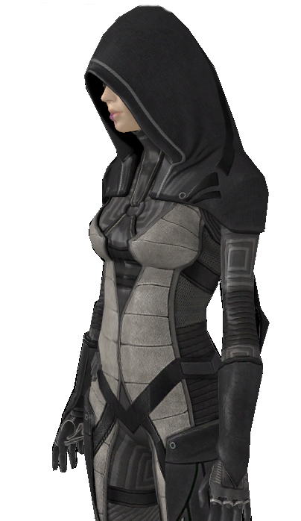
This skill is only available during character creation and provides 7 points that can be split between Dexterity and Personality.
Hide in Plain Sight
Type: Criminal
Pr: Street Skills 1, Street Smarts 1
Success: ½ INT/LOG + 10% per level
With this skill, a criminal can stalk someone or move freely in a crowd or through back alleys. It only works in urban areas or a busy space station.
The character being followed may get an Intuition check or have a counter skill, such as Situational Awareness and Spot a Mark, which may negate the criminal’s skill.
A character who also has Stealth and successfully uses that skill received a +10 percent modifier when using Hide in Plain Sight.
Money Laundering
Type: Criminal
Pr: Business Administration 1
Success: ½ INT/LOG + 10% per level
Money laundering is the process of transforming the proceeds of crime into ostensibly legitimate money or other assets.
This skill also covers the misuse of the financial system – involving things such as securities, credit cards and traditional currency – to finance terrorism, piracy and the evasion of other financial laws.
Pick Pockets
Type: Criminal
Addendum: Not only can a thief with this skill pocket items without notice, they also have the ability to hide smuggled items on their person or discretely plant items on someone else. This skill also gives a character a 10 percent bonus to preform magic tricks and to cheat at card and dice games. This bonus is cumulative with gambling, entertaining, stage magic and similar skills.
Spot a Mark
Type: Criminal
Pr: Street Skills 1, Street Smarts 1
Success: ½ INT/LOG + 10% per level
Through only a quick evaluation, the criminal can deduce someone's wealth or gullibility on sight. On top of being able to spot a careless person within a crowd, a thief may use this skill to spot stalkers and plain clothed police.
Street Skills (specify planet)
Type: Criminal
Pr: None
Street skills are about gangs and communication. It is a prerequisite for street-smarts and underworld connections. This skill set is limited to the planet the character grew up on, or had spent years living on.
A character using this skill set on unfamiliar ground will receive a -30 percent modifier on all Street Skills rolls. For each six months the character spends on a planet, immersed in its culture, the criminal’s success rate improves by 5 percent. After three years, the character will be an expert in the criminal ways of a planet.
Or the character can purchase a skill for a particular planet by using experience points after spending at least 6 months there. This skill covers the following sub-skills:
Sub-skill: Identify Local Colors
Success: Automatic (LOG)
This sub-skill allows one to identify a gang member, a gang-controlled area, and the meaning of tags and symbols. It may also help a criminal identify law enforcement officers who are trying to pose as a gang member.
Sub-skill: Street Talk
Success: Automatic (LOG)
Street talk allows one to speak and understand local slangs and cants.
Sub-skill: Fast Talk
Success: ½ PER/LDR + 10% per level – ½ target’s INT
This skill allows a character to talk his way out of a situation or to manipulate a conversation. The target’s experience and other skills may modify the success level. A character who also has Bluff/Haggle or Persuasion receives a +10 percent bonus when using Fast Talk.
Street Smarts (specify planet)
Type: Criminal
Pr: Street Skills 1
The Street Smarts skill that goes hand-in-hand with Street Skills. It is limited to the planet the character grew up on or has spent years living on.
A character using this skill set on unfamiliar ground will receive a -30 percent modifier on all Street Smarts rolls. For each six months the character spends on a planet, immersed in its culture, the criminal’s success rate improves by 5 percent. After three years, the character will be an expert in the criminal ways of a planet.
Street Smarts cover the following sub-skills:
Sub-skill: Find Information
Success: ½ LOG/INT + 10% per level
This sub-skill allows a character to use underworld connections to get information or a clue about a person, a place, or a group.
Sub-skill: Fence Goods
Success: ¼ LOG/INT + 10% per level
A character can find and deal with a Fencer (a black market dealer), or to convince a pawnshop owner to buy “hot” goods (if the local authorities enforce a ban on buying stolen goods).
Sub-skill: Find Goods
Success: ¼ LOG/INT + 10% per level
Allows one to use one's black market connections to find a controlled or restricted item – such as drugs, kaboomite, military-grade weapons, etc. – usually at an inflated price.

Swindle
Type: Criminal
Pr: Bluff/Haggle 1, Persuasion 1
Success: ½ PER/LDR + 10% per level – ½ Target’s INT score
This skill allows the thief to manipulate someone with lies and fast talk.
The target may have other skills/experience or racial abilities that may help them overcome the swindle attempt or cause them to fall for it easier.
For example, Dralasite characters can use their Lie Detection ability to prevent themselves from being conned.
Terror Tactics
Type: Criminal
Pr: Demolitions 1, Surveillance 1, Underclass 1
Terrorist skills are about covert action and preforming violent acts as a political statement or to undermine an enemy organization. This skill set covers the following sub-skills:
Sub-skill: Identify Fellow Members
Success: Automatic (INT/LOG)
The terrorist can visually spot other members within the same origination through subtle markings, gestures, and phrases.
Sub-skill: Monitor Security
Success: ½ LOG/INT + 10% per level
Similar to the Surveillance skill, it allows a terrorist to observe an area over time and make note of all the patrols and security systems.
Sub-skill: Demolitions: Creative Detonation
Success: ½ LOG/INT + 5% per level
This sub-skill allows a terrorist to maximize the potential for collateral damage or for dramatic effect.
Whitewash
Type: Criminal
Pr: Law 2
Success: ½ LOG/INT + 5% per level
This skill allows the criminal to remove and destroy incriminating evidence and make a death or injury look like an accident in order to befuddle or outright prevent a law enforcement investigation.
Origin: Star Frontiers Wiki (created by Malcadon 18:38, April 8, 2012 (UTC))

Section IX. Space Pirates
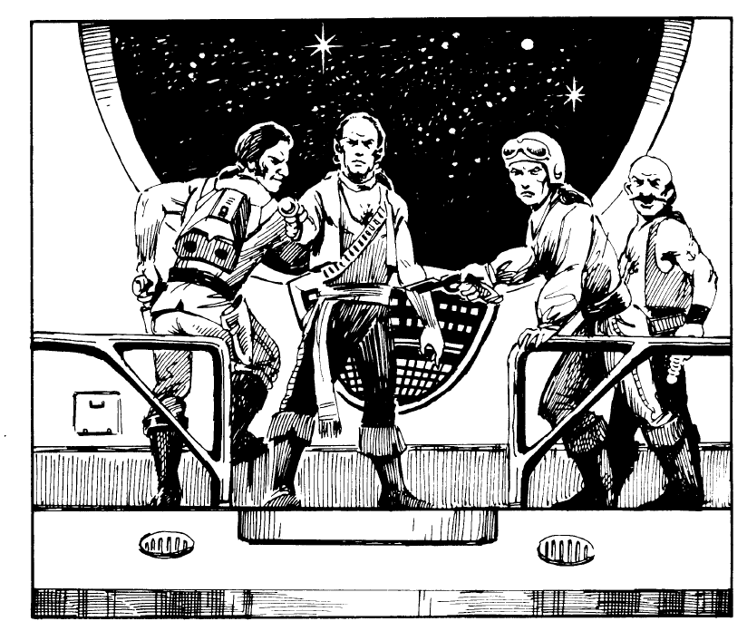
Pirates represent a major threat to the trade routes connecting the planets of the Frontier. Pirate ships are crewed by members of all Four Core races and even some minor races. Every inhabited star system has suffered from their scourge at one time or another.
The standard pirate tactic is a fast assault on a lone ship, usually a freighter or spaceliner. The pirates try to disable the victim's drives and maneuver jets and then board her.
Everything of value is removed from the ship, including passengers and crew who can be used as slaves at the pirate base or held for ransom. Sometimes the passengers and crew are not kidnapped, but left on board the drifting hulk, hoping for rescue before their life support runs out.
Pirate ships usually are small and fast. Assault scouts and frigates are the preferred pirate vessels although they often they use corvettes. Whatever type of ship is used, it will be heavily armed. However, pirates may also use converted freighters or starliners to lure unsuspecting Spacers into a trap with false distress signals.
Asteroids, uninhabited planets, unknown regions of outpost worlds and moons all might serve as pirate bases. These facilities usually are not very well developed, since the pirates must be prepared to escape quickly if ships of the Spacefleet or a planetary militia suddenly attack.
Some lightly populated planets have governments are actually run by pirates. Because of the charter of the UPF, the Spacefleet is prohibited from taking direct action against these worlds, and must limit itself to intercepting pirate ships as they go about their unlawful business. Outer Reach in the Dramune system is the most significant of these pirate governments.
Raider Characters
Practically anyone can become a space pirate, but like Spacers there is a certain breed of criminals who’ve been born into the space-faring class who are not bound by the restrictions of a single planet or even the Frontier. These criminals call themselves Raiders or buccaneers or even swashbucklers like the sea pirates of old. They are predators, plowing the space lanes, seeking fame and fortune often at the cost of innocent lives.
Like Spacers, Raiders automatically receive the skill Adroitness, which provides 7 points that can be split between Dexterity and Logic. Pirates also learn early starship skills at a lower cost because they cut corners. Due to their more rudimentary training, their chance of success is less than an academy-trained recruit and, often, they have a much more difficult time learning higher level skills.
Although the holovid movies make the space pirate life seem glamorous, its desperate and cut-throat nature often translates into a shortened lifespan for many a Raider.
Raiders can chose between four starting careers including: Star Navigator (Astrogator), Fix-It (Engineer), Shooter (Gunner) and Rocketeer (Pilot). These careers include ten level 1 skills for the cost of only 8 experience points. Two experience points are left over for players to individualize their characters.
Or a player is free to design their pirate characters differently without the benefits of a starting career.
Space Pirate: Non-Spacers Skills Chart
Raider characters can use experience points to purchase or improve these skills using the normal Zebulon’s Guide skill advancement chart.
Alertness | Appraisals | Bribery
Bluff/Haggle | Business Administration | Communication Devices
Computers: Basic | Computers: Advanced | Computers: Programming
Computers: Repair | Dramatics/Rhetoric | Engineering: A.C.E.
Engineering: Energy Generation | Engineering: Hyd. And Mech. | Entertaining
Etiquette | Forgery | Gambling
Gemology | General Lore | Law
Management | Machinery | Money Laundering
Occult Knowledge | Power Read | Sciences: Physical
Sciences: Space | Sensor Operations (Ops) | Ship Onboard Systems Operations (SOSO)
Survival: Zero-G | Underclass | Vehicles: Atmospheric
Vehicles: Space | Weapons: Beam | Weapons: Melee
Weapons: P.G.S. | Weapons: Thrown | Weightless Combat

Space Pirate: Professional Skills Chart
Adroitness * | Astrogation | Engineer: Damage Control
Engineer: Modify Ship Design | Engineer: Stress Analysis | Gunnery: Beam Weapons
Gunnery: Rocket Weapons | Gunnery: Selective Targeting | Smuggling Skills
Smuggling Smarts | Star Pilot I | Star Pilot II
Star Pilot III | Star Pilot IV | Star Pilot: Evasion
Star Pilot: Increase Accuracy of Forward Firing Weapons | Star Pilot: Increase Maneuver Rating | System Navigation
* Raider characters receive this as their starting skill.

Star Navigator. An astrogator by another name, you are almost ready to plot jumps to known star systems. Skills include: Computers: Basic 2, Sciences: Physical 2, Sciences: Space 2, and System Navigation 1.
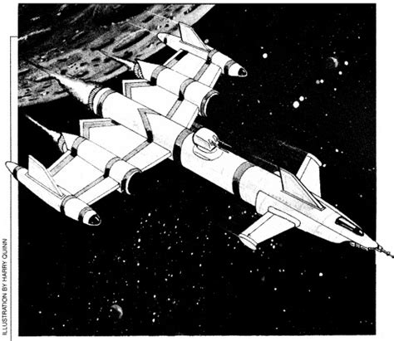
Fix-It. You’ve got one of the most important duties on the “floating tin cans in space” – the task of finding and repairing damaged components and stop air leaks. If you don’t succeed, your ship and crew could be doomed. Initial skills: Communication Devices 1, Computers: Basic 1, Computers: Advanced 1, Computers: Programming 1, Computers: Repair 1, Machinery 2, Power Read, and Ship Onboard Systems Operations (SOSO) 1.
Shooter. Raider gunners increase a spaceship's effectiveness in combat. Unlike a Spacer, the pirate shooter has already learned the basic skills needed to fire ship weapons – at practically the exclusion of all other abilities, hence they have a slightly worse chance to hit and a harder time advancing to higher levels. Shooters are often used in boarding parties. Initial skills: Weapons: Beam 2, Weapons: Missile 2, Weapons: Melee 1, and Gunnery (Beam or Rocket) 1. Shooters also double as boarding party combatants.
Rocketeer. Entry-level Raider pilots are affectionately called “Rocketmen.” You’re not quite ready to drive a big starship, but you’re on your way there. Initial skills: Computers: Basic 1; Sensor Operations 1; Star Pilot 1, level 1; Vehicle: Atmospheric 1; Vehicle: Space 1; Ship Onboard Systems Operations (SOSO) 1; Weapons: (Beam or PGS) 1; and Weightless Combat 1.
Space Pirate Skill Advancements
Raiders advance their non-spacer skills at the normal rate, but it is harder to advance space-specific skills such as Space Navigation (Astrogation), Fix-It (Engineering), Shooter (Gunnery) and Rocketeer (Piloting) than it would be for a normal Spacer. See chart below.

Spaceship Skill Cost Chart
 | Cost for Raiders | Cost for Non-Raiders | Navigation Cost for Raiders | Navigation Cost for Non-Raiders
Level 1 | 3 | 6 | 4 | 12
Level 2 | 6 | 12 | 9 | 18
Level 3 | 10 | 20 | 18 | 30
Level 4 | 20 | 30 | 26 | 40
Level 5 | 30 | 50 | 40 | 60
Level 6 | 40 | 60 | 60 | 80
Level 7 | 60 | 80 | 80 | 120
Level 8 | 80 | 100 | 100 | 160

Raider General Skills
These skills are very much like their Spacer counterparts, except the prerequisites and the chances for success may be very different. For a full description of each skill, see the Knight Hawks section.
Adroitness*
Success Rate: Automatic (LOG and DEX)
Pr: Raider Profession
See Knight Hawks. Raider characters receive an additional 7 points to be distributed between their Logic and Dexterity scores.
Sensor Operations
Success Rate: Automatic (LOG)
Pr: Computers: Basic 1
See Knight Hawks skills for a description.
Ship Onboard Systems Operations (SOSO)
Type: Pirate
Pr: Proper tools
Sub-skill: Ship/Station Orientation
Success Rate: 1/3 LOG/INT + 5% per level
Sub-skill: Emergency Repairs
Success Rate: 1/3 LOG + 5% per level
See Knight Hawks. If a character learns Computers: Basic 1, his success rate increases to normal Spacer levels.
Smuggling Skills (specify region: Frontier, S’sessu space, The Rim, etc.)
Pr: None
Smuggling skills are all about pirate activities and communications. It is a prerequisite for smuggling smarts. Similar to Street Skills, this is the expertise needed by a pirate to know how to recognized and communicate with other pirates and smugglers, where to find information and sell illegal goods at various spaceports around the Frontier.
If used in a region of space that the pirate is unfamiliar with, the raider receives a -30 percent penalty on all rolls. For each six months that a pirate spends in a region, learning the culture and customs, he the penalty is lowered by 5 percent. By the end of three years, the character will be very familiar with the area and is no longer penalized.
Or the character can purchase Smuggler Skills for a particular region by using experience points. This skill covers the following sub-skills:
Sub-skill: Identify Pirate Bands and Gang Colors
Success: Automatic (LOG)
This sub-skill allows one to identify a pirate or gang member, a gang-controlled area, and the meaning of tags and symbols. It may also help a raider identify law enforcement officers who are trying to pose as a space pirate.
Sub-skill Space Talk
Success: Automatic (LOG)
Space talk allows one to speak and understand Frontier spacer and pirate slangs and cants.
Sub-skill: Fast Talk
Success: ½ PER/LDR + 10% per level – target’s INT
Allows one to talk their way out of a situation with customs or law enforcement officials, or to manipulate a conversation. The target’s experience and other skills may modify the success level.
Smuggling Smarts (specify region: Frontier, S’sessu space, The Rim, etc.)
Pr: Smuggling Skills 1; Smuggling Smarts cannot exceed the character’s Smuggling Skills level.
Smuggling Smarts are a set of skills that goes hand-in-hand with the Smuggling Skills expertise for use in the Frontier. If a raider uses this skill set in an unfamiliar region of space, he will receive an initial -30 percent penalty on all skill rolls.
For each six months that a pirate spends in a region, learning the culture and customs, he the penalty is lowered by 5 percent. By the end of three years, the character will be very familiar with the area and is no longer penalized.
Or the character can purchase Smuggler Skills for a particular region by using experience points. This skill covers the following sub-skills:
Sub-skill: Find Information
Success: ½ LOG/INT + 10% per level
This sub-skill allows a character to use underworld connections to get information or a clue about a person, a place, or a group.
Sub-skill: Fence Goods
Success: ¼ LOG/INT + 10% per level
A character can find and deal with a Fencer (a black market dealer), or to convince a pawnshop owner to buy “hot” goods (if the local authorities enforce a ban on buying stolen goods).
Sub-skill: Find Goods
Success: ¼ LOG/INT + 10% per level
Allows one to use one's black market connections to find a controlled or restricted item (like drugs, kaboomite, military-grade weapons, etc.) – usually at an inflated price.
Survival Zero-G
Success Rate: Special (DEX/RS)
Pr: None
See Knight Hawks.
System Navigation
Type: Spacer
Success Rate: ½ LOG + 10% per skill level
Pr: Astronomy 1, Computers: Basic 2, Mathematics 1
See Knight Hawks.
Vehicles: Atmospheric
Success Rate: 100% (RS)
Pr: None
See Library of Skills for more information.
Vehicles: Space
Success Rate: 100% (RS)
Pr: Vehicles: Machine 1, Machinery: Operate (for cargo arms)
This skill enables a spacer to operate any space vessel support vehicle such as a launch, workpod, or a cargo bay loader arm. If a character learns Vehicles: Machinery 1 and Machinery: Operate 1, then normal Knight Hawks rules apply.
Otherwise, the character must make a Reaction Speed check to successfully use EVA equipment and they do not get a positive modifier when using a rocket pack nor do they take half damage from colliding with objects.
Weightless Combat
Success Rate: Special (DEX)
Pr: N/A
See Knight Hawks.
Space Pirate Specialist Skills:
Star Navigator (Astrogator)
Raiders trained in star navigation can make the complicated calculations required to take a starship on a safe course through the Void. They also have a chance to pinpoint their location in the galaxy if, for some reason, an interstellar jump deposits them somewhere other than their intended destination. All of the skills listed below are sub-skills of star navigation; because of its complicated nature, this skill costs more than other Knight Hawks skills. Since Raider captains often capture and keep alive normal astrogators who are better trained than Star Navigators. If a Star Navigator actually acquires all of the basic skills of a normal astrogator – including Computers: Advanced 1 and Sciences: Space level 3, then his success rate would be the same as an astrogator.
Pr: Computers: Basic 2, Sciences: Physical 2, Sciences: Space 2
INTERSTELLAR DISTANCE CHART
- - - - - - - - - - Horizontal Separation - - - - - - - - - - - -
Vertical Separation | 0 | 1 | 2 | 3 | 4 | 5 | 6 | 7 | 8 | 9 | 10 | 11 | 12 | 13 | 14 | 15
0 | 0 | 1 | 2 | 3 | 4 | 5 | 6 | 7 | 8 | 9 | 10 | 11 | 12 | 13 | 14 | 15
1 | 1 | 1 | 2 | 3 | 4 | 5 | 6 | 7 | 8 | 9 | 10 | 11 | 12 | 13 | 14 | 15
2 | 2 | 2 | 3 | 4 | 4 | 5 | 6 | 7 | 8 | 9 | 10 | 11 | 12 | 13 | 14 | 15
3 | 3 | 3 | 4 | 4 | 5 | 6 | 7 | 8 | 8 | 9 | 10 | 11 | 12 | 13 | 14 | 15
4 | 4 | 4 | 4 | 5 | 6 | 6 | 7 | 8 | 9 | 10 | 11 | 12 | 13 | 14 | 14 | 15
5 | 5 | 5 | 5 | 6 | 6 | 7 | 8 | 9 | 9 | 10 | 11 | 12 | 13 | 14 | 15 | 16
6 | 6 | 6 | 6 | 7 | 7 | 8 | 8 | 9 | 10 | 11 | 12 | 12 | 13 | 14 | 15 | 16
7 | 7 | 7 | 7 | 8 | 8 | 9 | 9 | 10 | 11 | 11 | 12 | 13 | 14 | 15 | 16 | 16
8 | 8 | 8 | 8 | 8 | 9 | 9 | 10 | 11 | 11 | 12 | 13 | 14 | 14 | 15 | 16 | 17
9 | 9 | 9 | 9 | 9 | 10 | 10 | 11 | 11 | 12 | 13 | 13 | 14 | 15 | 16 | 17 | 17
10 | 10 | 10 | 10 | 10 | 11 | 11 | 12 | 12 | 13 | 13 | 14 | 15 | 16 | 16 | 17 | 18
11 | 11 | 11 | 11 | 11 | 12 | 12 | 12 | 13 | 14 | 14 | 15 | 15 | 16 | 17 | 18 | 19
12 | 12 | 12 | 12 | 12 | 13 | 13 | 13 | 14 | 14 | 15 | 16 | 16 | 17 | 18 | 18 | 19
13 | 13 | 13 | 13 | 13 | 14 | 14 | 14 | 15 | 15 | 16 | 16 | 17 | 18 | 18 | 19 | 20
14 | 14 | 14 | 14 | 14 | 14 | 15 | 15 | 15 | 16 | 17 | 17 | 18 | 18 | 19 | 20 | 20
15 | 15 | 15 | 15 | 15 | 15 | 16 | 16 | 16 | 17 | 17 | 18 | 19 | 19 | 20 | 20 | 21

Sub-skill: Chart New Routes
Success Rate: 1/3 LOG + 10% x skill level - 12% x light years
A star navigator has a chance to chart a new route to a system. New routes may be shortcuts between inhabited systems that are not directly connected (Prenglar and White Light, for example), or they may be routes to unexplored star systems.
If a star navigator guides a ship successfully on an uncharted route, he can regard that route as charted if he ever travels it again. However, the route is charted in only one direction.
To completely chart the route, the star navigator must guide the ship back to its starting point along the same path. If he fails this skill check, the ship misjumps (see Misjumping in the Ship Movement section). Star navigators get a +5 percent bonus for using high-quality navigation equipment when trying to chart a new route.
Pirates, posing as explorers, can sell star route information to the UPF for the standard rate of 100,000 Cr; however, most sell the information to other pirates or mega corporations for far more money. See Knight Hawks rules for more information.
Sub-skill: Find Location
Success Rate: 1/3 LOG + 10% per level
When a ship misjumps, either because the star navigator spent too little time plotting the jump or because the ship was following an uncharted route, the ship will emerge somewhere other than its intended destination (see Misjumps in the Ship Movement section). He then must try to figure out where the ship is.
The star navigator can easily determine his position if the ship enters a colonized system, because all of the inhabited systems are charted in detail. The astrogator will recognize a charted system after only 1d10+2 hours of calculation.
A very simple way for a ship to find out whether a system is colonized is to broadcast a normal radio message. If anyone answers, the characters know there are intelligent creatures around. Unless the ship is very near a planet, however, the radio message may take several hours to reach a possible colony, and the reply will take just as long to return. Of course, any intelligent creatures who answer the message will also know that the characters are in system.
If the system is uncharted, the stars will appear in unfamiliar patterns and will be difficult to recognize. Unless the astrogator can determine the ship’s position, the crew may never see home again.
Determining the ship's position in an uncharted system takes 3d10 x 10 hours of calculations. The referee rolls d100. If the result is equal to or less than the star navigator’s success rate for this skill, the he will know exactly where the ship is when he finishes his calculations. Like course calculations, these 3d10 x 10 hours do not include time for sleep.
If the he does not pass the skill check, the referee must consider how close the roll was. If the roll was reasonably close, the star navigator will realize that he cannot locate the ship. If the roll was very much higher than the success rate (at least 30 or 40 points higher), the referee may decide to give the star navigator false information.
If the navigator cannot fix the starship's position, the ship can jump to another star and try again. The referee should simply move the ship to another randomly chosen star, because it will misjump automatically. The star navigator has a -20 percent penalty on his location roll at the new system and, if the ship must jump blind again, an additional -10 percent for each new system it enters. (By making blind jumps, the ship's position becomes more and more confused.) The referee should feel free to expand the Frontier map if a ship jumps off the edge.
A star navigator using high-quality equipment gets a +5 percent bonus when trying to fix the ship’s position.
If a ship misjumps to a star system that has never been explored, the route to that system is not considered charted or explored. Even if the he locates the ship's position, he must also successfully chart a new route out of the system in order to leave safely.
Sub-skill: Plot Interstellar Jumps
Success Rate: 100% (LOG) on charted route with proper preparation
A ship that makes an interstellar jump must carry a star navigator, or the pilot will not be able to predict where the ship will exit the Void. The time needed to make course calculations increases for long jumps, because even small errors become very serious as the distance increases. Normal plotting time for a jump is 12 hours per light year. A character above a level 3 in Star Navigation can shave 1 hour off of the total time per skill level.
For example, a level 1 star navigator plotting an 8 light-year jump must spend 96 hours performing calculations before the ship could accelerate to jump speed. (8 LY x 12 hours = 96 hours.) Meanwhile, a level 8 star navigator can make the same calculations in 88 hours.
This time must be spent actually making calculations. The referee should remember that navigators need to sleep sometime. Advanced astrogation equipment may also trim jump plotting times. If a player wants to work without sleeping, the referee can make a secret Stamina check – if the character fails, his calculations are wrong and the ship will drift off course.
If a jump is made along one of the established travel routes marked on the Frontier Sector map, and the star navigator spends 12 hours per light-year making the proper course adjustments, there is no risk that the ship will leave the Void anywhere other than its planned destination.
Sub-skill: Risk Jumping
Success Rate: See below
If for some reason a star navigator does not spend the full time plotting each light-year of an interstellar jump, there is a chance the ship will drift off course. Jumping without sufficient preparation is called Risk Jumping, or "smoking the jump."
The chance that a ship will reach its destination without sufficient course preparation depends on the navigator's skill level, his Intuition score and the amount of time he spends planning the ship's course. To determine the exact percentage chance that the jump will be successful, follow the procedure below:
- First calculate the total hours normally needed to calculate the jump. This is the base number for a 100 percent success rate.
- Divide the total number of hours the navigator actually spent preparing the course by the base number, rounding up. This is now the modified percentage for a successful jump.
- Add one-fourth of the navigator’s Intuition score (rounding up to the nearest whole number) to the result from step 2.
- Add the navigator's skill level times 5 percent to the result from step 3. The result is the chance that the jump will be successful and the ship will arrive at the target system.
The navigator rolls d100, and if the result is equal to or less than the chance that the jump will succeed, then the ship arrives at its planned destination. Otherwise, the ship has exited the Void somewhere else (see Fix Location sub-skill).
Two restrictions apply to this process. First, if the navigator spends fewer than 12 hours plotting each light-year, a roll of 96-100 always means the ship misses its mark, even if his modified chance to succeed is above 100.
Second, if the navigator spends fewer than three hours planning each light-year, the ship will misjump automatically.
If the navigator is using high-quality astrogation equipment (described in the Equipment section), he can add 5 percent to his chance to lay the course properly. This applies only to the most expensive equipment available.
Fix-It (Spaceship Engineering)
Fix-It is the slang term for a space pirate engineer. Such a character is responsible for the maintenance, repair and modifications of spaceships. A skillful fix-it character often can save a damaged ship from destruction. Because they have more rudimentary knowledge, a Fix-It has a lower chance of success than a normal engineer. If the character ever acquires the basic knowledge found in the Knight Hawks skills section (Engineering: Energy Generation 1, Engineering: Hydraulics and Mechanical 1), then his chance of success will improve to normal.
Fix-It: Damage Control
Success Rate: ¼ INT + 10% per level
Pr: Sciences: Physical 2, Engineering: A.C.E. 2, Machinery 2
A fix-it can greatly aid the crew of a ship in repairing damage caused by combat or accidents but unlike a normal engineer, he cannot increase the ship's Damage Control Rating (DCR).
The fix-it can only use his repair ability on only one repair per repair turn (he can oversee only one thing at a time).
In order to use his damage control ability, the fix-it must be working on the repairs during all three turns (30 minutes) preceding the repair turn.
For example, a character who serves as both a ship's rocketeer and fix-it cannot be flying the ship and making repairs at the same time.
If a ship is carrying more than one fix-it, each can be working on a separate repair at the same time.
Damage Control allows a fix-it to affect every sort of repair to a damaged or malfunctioning system onboard a ship. This could be as minor as restoring lighting or power to a section of the ship, or as major as patching hull-breaches, repairing radiation leaks, and overhauling engines.
Fix-It: Modify Ship Design
Success Rate: 1/3 LOG + 10% per level
Pr: Science: Physical 2, Engineer: A.C.E. 2
A fix-it can make non-standard modifications to starships, sometimes exceeding their normal limits, but this can later cause problems or a disaster when jerry-rigged systems fail in combat or due to lack of maintenance. Often they work without the resources of a properly equipped construction center.
Fix-It’s Level | Qualified to Modify
1 | Shuttles of all types
2 | System ships of all types
3 | Starships of hull size 3 or smaller
4 | Starships of hull size 6 or smaller
5 | Starships of hull size 9 or smaller
6 | Starships of hull size 15 or smaller
7-8 | Starships of all sizes
However, a Raider Fix-It who can successfully modify ships is often in high demand and very often well paid. The referee must determine whether any NPC engineers are available for hire and how much they get paid; 800 Cr per point of hull size is standard, but this can vary with the number of fix-its available at a pirate base.
As a fix-it reaches higher levels, he can design larger ships. The Ship Design Qualification Table lists the types of ships he can modify at various skill levels.
A fix-it must spend 10-20 days x the hull size of the ship to complete the desired modifications. The entire design of a modification does not need to be completed before construction work can start.
Note: Engineer: ACE, Engineer Energy Generation and Sciences: Physical must be bought at the non-professional skill cost.
Fix-It: Stress Analysis
Pr: Fix-It: Damage Control
Sub-skill: Prevent Ship Breakup
Success Rate: -4% per level
Sub-skill: Troubleshooting/Detect Engine Failure
Success Rate: ¼ LOG + 10% per level
Because of their keen understanding of the forces at work on the hull of a spaceship, fix-its can advise a pilot on how to accelerate and maneuver a damaged ship without tearing the hull apart with excess stress. Having an experienced fix-it on board a ship modifies the chance that the ship will break apart when damaged.
The player controlling the ship multiplies the engineer's skill level by 5 percent and subtracts the result from the normal chance that the ship will break up.
Example: Jack the Knife is a 3rd level fix-it. His assault scout has taken 13 hull hits in combat. This is 6 hits above the 50 percent mark for the 15-hull point ship. In order to get away, the pilot uses full acceleration (5) and makes one turn. The chance that the ship will break apart is (5+1) x 6 percent = 36 percent. Jack's advice reduces this by (3 x 5 percent) = 15 percent, the actual chance the ship will break up is only 21 percent.
A fix-it cannot use this skill during a turn when he is making or overseeing repairs.
In addition to the explicit Knight Hawks rules, Stress Analysis allows a fix-it to inspect a specific system of a ship and make an assessment of its chances of malfunctioning in the near future. This may be done following combat or just as a routine inspection. It cannot be done during combat. Minor systems take 1 hour to inspect, after which the roll is made; major systems take 1d10 hours. This sub-skill also covers the ability described in Knight Hawks pg. 13, in which an engineer can detect when an engine is about to fail from not being overhauled, and can do so in time to shut it down.
Shooter (Spaceship Gunnery)
A ship's weapons can be fired by the ship's computer if no characters with Gunnery skill are aboard, but ship gunners increase a spaceship's effectiveness in combat. The gunnery skills are:
GUNNERY SKILL COVERAGE CHART
Skill | Weapons Covered
Energy Weapons | Laser Cannons
 | Laser Batteries
 | Proton Beam Batteries
 | Disruptor Beam Cannons
Rocket Weapons | Torpedoes
 | Assault Rockets
 | Rocket Batteries
- Improve Accuracy
- Selective Targeting.
When a character spends experience points for the Shooter skill, he must specify whether he is learning Energy Weaponry or Rocket Weaponry. The weapons covered by these two skills include:
Shooter: Beam Weapons
Success Rate: 4% x skill level + KH Combat Table percent’s
Pr: Weapons: Beam 2
This skill subsumes “improve accuracy” and “selective targeting” under it. The skill chance (-4 percent x skill level added to combat charts) assumes the “improve accuracy” component of this skill.
Selective targeting subtracts -30 percent from the attack roll as per the skill description in Knight Hawks.
Shooter: Rocket Weapons
Success Rate: 4% x skill level + KH Combat Table percent’s
Pr: Weapons: Missiles 2
See Knight Hawks. This skill subsumes “improve accuracy” and “selective targeting” under it. The skill chance (-4 percent x skill level added to combat charts) assumes the “improve accuracy” component of this skill. Selective targeting subtracts -30 percent from the attack roll as per the skill description in Knight Hawks.
Shooter: Improved Accuracy
Success Rate: +4% x skill level
Pr: Gunnery: Beam Weapons or Gunnery: Rocket Weapons
This skill gives a gunner a better chance to hit a target with ship-mounted weapons. A gunner can apply this skill to only one weapon per turn. The bonus can be combined with the pilot's Forward Firing Weapons bonus, however.
When player-character shooters are onboard spaceships, use the lower percentages in the shaded columns of the Advanced Game Combat Table. The higher, un-shaded percentages are adjusted to reflect the skills of NPC gunners onboard military ships.
Shooter: Selective Targeting
Success Rate: -35% to hit
Pr: Gunnery: Beam Weapons or Gunnery: Rocket Weapons
This skill must be purchased separately for Gunnery: Beam Weapons and Gunnery: Rocket Weapons but it allows a gunnery expert shoot at a specific EXTERNAL system on an enemy ship. Only those components visible from outside the ship can be attacked, so Life Support systems, astrogation controls, damage control equipment, computers and electrical systems cannot be targeted selectively.
To use this skill, the attacking ship and its target must be in the same hex. The gunner declares what system he is targeting, and rolls to hit with a -35 percent modifier, in addition to all other modifiers that apply. The gunner can use his Improve Accuracy skill with Selective Targeting. If the shot hits, the damage is applied directly to the targeted system as described on the Advanced Game Damage Table.
If the shot misses, it is considered a clean miss and causes no damage. If the system that is hit can receive several grades of damage on the Advanced Game Damage Table, a random die roll should be used to determine how badly the system is damaged. It the ship's hull is hit, there is a 50 percent chance it will suffer double damage.
EXAMPLE: A pirate shooter using selective targeting hits the drive of an enemy ship. According to the damage table, this can reduce the ship's ADF by 1, by half of its total, or completely to 0. In this case, the referee decides that the gunner must roll 1d10. A result of 1-3 means 1 ADF is lost, 4-6 means one-half of the ship's ADF is lost and 7-9 means the entire ADF is lost. A 0 is ignored and rerolled.
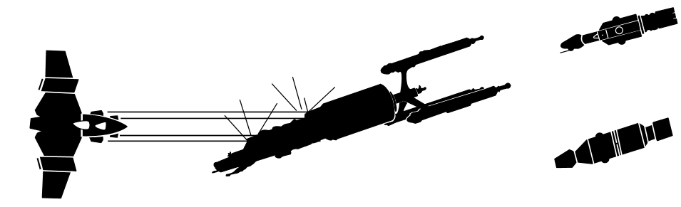

Rocketeer (Piloting)
Rocketeering (piloting) skill allows a character to fly a spaceship. Rising levels of piloting skill represent both an improvement in flying ability and the ability to handle larger craft. Raiders, however, are not as well skilled at piloting larger vessels.
Rocketeering 1 (Hull Size 1-3)
Success Rate: ½ RS + 10% per level
Pr: Computers: Basic 1, Vehicles: Atmospheric 1, Vehicles: Space 2
This skill enables a Rocketeer to fly any spacecraft of hull size 3 or smaller. Excelling in this skill means the pilot is adept at maneuvering smaller, faster vessels as well as leaving and re-entering an atmosphere. Other skills include docking and refueling the ship. Ships that can operate within an atmosphere are controlled using the Vehicles: Atmospheric skill when in an atmosphere.
Many Star Pilots specialize in this skill to become crack fighter pilots or operate smaller commercial or smuggling ships. This skill covers the expertise of operating a space vessel in complex maneuvers including docking, landing, and take-off from planets (not including flying the vessel as an atmospheric craft), acceleration and deceleration, orbiting, evading missile fire, improving accuracy of forward-firing weapons, and improving the MR of a space-vessel in a Zero-G environment.
By dividing the separate skills into the operation of progressive hull sizes, pilots could become very adept at flying a huge capital ship, which doubtless involves its own distinct considerations, but have little experience piloting a snub-fighter and vice-versa.
Rocketeering 2 (Hull Size 4-8)
Success Rate: ½ RS + 10% per level
Pr: Star Pilot 1, level 1
This skill specializes in the techniques necessary for piloting space craft with hull sizes ranging from 4 to 8. Excelling in this skill means the pilot is adept at maneuvering larger ships like frigates and destroyers.
Rocketeering 3 (Hull Size 9-12)
Success Rate: 1/3 RS + 10% per level
Pr: Star Pilot 2, level 2
This skill specializes in the techniques necessary for piloting space craft with hull sizes ranging from 9 to 12. Other skills include docking and refueling the ship. Excelling in this skill means the pilot is adept at maneuvering even larger ships like assault transports and spaceliners.
Rocketeering 4 (Hull Size 13+)
Success Rate: 1/3 RS + 10% per level
Pr: Star Pilot 3, level 4
This skill specializes in the techniques necessary for piloting spacecraft of hull size 13 or larger. Other skills include docking and refueling the ship. Characters at this level could become very adept at flying a huge capital ship, which doubtless involves its own distinct considerations.
Rocketeering: Evasion
Success Rate: -3% x skill level from ship's chance of being hit
Pr: Star Pilot 1
This skill need only be purchased once for use on any starship the rocketeer has expertise in flying. The pilot of a fighter or assault scout can increase the ship's inherent ability to avoid enemy fire. As explained in the Knight Hawks rules, fighters and scouts can try to evade enemy torpedoes by using their full maneuver rating to dodge.
Besides the enemy's usual modifier for shooting at an evading target, there is an additional modifier of -3 percent x the evading pilot's skill level.
For example: Dirk the Dark Hand is a 2nd level fighter pilot. If he evades, the total modifier is -31 percent: -25 percent because the fighter has an MR of 5, and (-3 percent x 2) = -6 percent because of Dirk's pilot skill.
Rocketeering: Increase Accuracy of Forward Firing Weapons
Success Rate: +3% x skill level
Pr: Star Pilot 1
This skill need only be purchased once for use on any starship the pilot has expertise in flying. The pilot of a ship that carries assault rockets, a laser cannon or a disruptor beam cannon can add 3 percent x his skill level to that weapon's chance to hit. This reflects the pilot's skill in lining up the weapon for an accurate shot
Rocketeering: Increase Maneuver Rating
Success Rate: 10% x skill level
Pr: Star Pilot 1
This skill need only be purchased once for use on any starship the pilot has expertise in flying.
On a given turn, a pilot has a chance to turn his ship more than its MR will allow. This chance is 10 percent per level of the pilot. If the skill check is successful, the pilot can make an additional 60 degree (one hexside) facing change during that movement.
This skill and the evasion bonus cannot be used during the same turn. It cannot be used by a pilot whose ship has no MR points (due to damage, etc.)
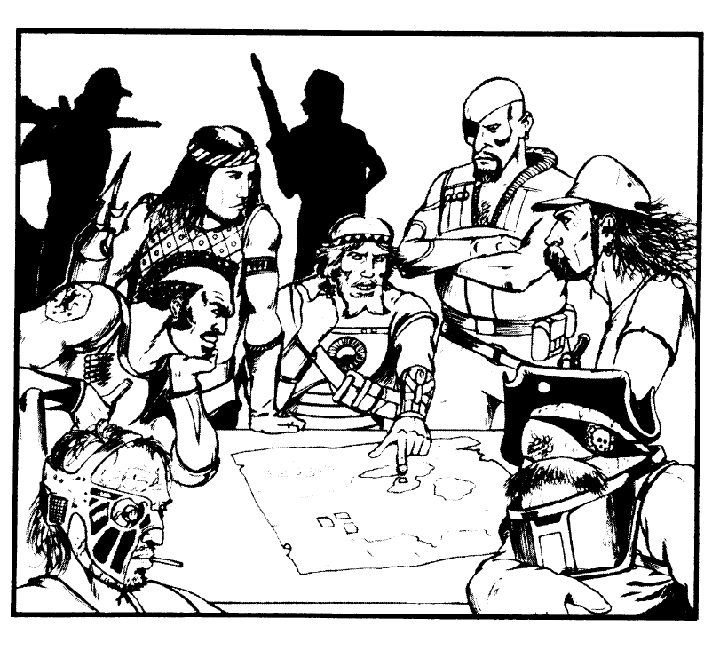



Investigation is a nonprofessional skill for a headhunter even though he starts out with level 1.
http://starfrontiers.wikia.com/wiki/Pirates

